Dear Federal Programs Directors,

On September 25, the United States Department of Education (US ED) [announced](http://blogs.edweek.org/edweek/campaign-k-12/Secretary%20DeVos%20Letter%20to%20Chief%20State%20School%20Officers%2009%2025%202020.pdf) it would not appeal the cancelation of the ESSER “Interim Final Rule” (IFR) by the Federal District Court for the District of Columbia.

The following instructions address the new measures necessary for ESSER compliance, including:

1. **Recalculations due to reversion to “traditional” Title I-A equitable share calculation processes**
2. **Disposition of equitable share based on private school “total enrollment” already obligated or spent for the private school**
3. **Options for establishing a private school’s qualifying low-income student count if not previously established (household income surveys, or financial aid data)**
4. **Private school affirmation/signature for new ESSER equitable services plan**

--------

1. **Recalculations due to reversion to “traditional” Title I-A equitable share calculation processes**

October 30th is the new target date for District completion of ESSER Applications.

With the cancelation of the IFR, the method for calculating ESSER equitable share has reverted to the “traditional” Title I-A equitable share calculation method, including:

* The private school must determine the number of its students considered “low-income,” and each such student must also reside at an address that would place him/her at a Title I-A served school and grade level if he/she attended public school. Students meeting these criteria are included in the private school’s qualifying low-income student count, and funds generated by these students are apportioned to the private school they attend.
* The District (the “District of Residence”) where such a qualifying private school student resides must contribute that student’s per-pupil share to the District (the “Fiscal Agent District”) administering the ESSER equitable services program at the private school (see details below).

Because the IFR ignored the residence criteria (underlined in bullet one above) of private school students for equitable share calculations, and District contributions to equitable share are now affected by student residence criteria, all Districts must check and recalculate, if necessary:

* Equitable share amounts for private schools, and
* Amounts a District must contribute to another District for any qualifying private school students who reside in the District, but drive to attend a private school located in another District.

In line with the “traditional” Title I-A process, the District where the private school is located administers the equitable services program at the private school, but must receive contributions from Districts where qualifying private school students reside.

* The administering District is known as the “Fiscal Agent District.”
* A private school student may reside in one District (the “District of Residence”) but drive to a private school located in another District (the “Fiscal Agent District”).

* In this case, if the Fiscal Agent District identifies the student as “low-income” during its consultation with the private school, and finds that the student’s residence address is in a different District (the “District of Residence”), the Fiscal Agent District will send a list of addresses and grade levels of such identified students to the District of Residence.

* The District of Residence verifies that these identified low-income private school students would have attended a Title I-A served school and grade level in their District of Residence had the students attended public school there according to their residence addresses.
* Upon such verification, the District of Residence contributes the per-pupil share for that student or students to the Fiscal Agent District.
* A Memorandum of Understanding (MOU) will be conveyed to the District of Residence by the Fiscal Agent District when the list for verification is conveyed.

1. **Disposition of equitable share based on a private school’s “total enrollment” already obligated or spent for the private school**

A minority of private schools had an ESSER equitable share calculated by the IFR’s “total enrollment” method.

New obligation and expenditure of these funds by LEAs for such private schools must halt immediately, and each private school’s equitable share recalculated as discussed in 1., above.

However, some or all of the equitable share previously established by “total enrollment” may have already been spent or obligated for expenditure (i.e., committed to contractual payments to vendors, or otherwise formally committed to expenditure by placement of orders, etc.).

* These already-obligated and already-spent funds (obligated or spent between March 13 and September 28) were used in reliance on the requirements of the law as it existed at the time (as mandated by the enforcing executive branch authority, US ED) and will be considered properly used in the ESSER program, consistent with US ED’s announcement on September 25 that it “will not take any action against States or local Districts that followed the guidance and/or the IFR prior to notice of the court’s decision [abolishing the IFR].”
* If, upon recalculation of a private school’s equitable share, a greater amount has already been obligated/spent for the private school, then the private school will have no equitable share remaining.
* If, however, a difference remains between already-obligated/spent equitable share and the private school’s recalculated amount, then the remaining difference will be available for ESSER equitable services.

1. **Options for establishing a private school’s qualifying low-income student count if not previously established (household income surveys, or financial aid data); private school affirmation of new ESSER equitable services plan**

Private schools that have already established low-income student counts will be subject to slight alterations of their equitable shares, due to new residence criteria (see, 1., above).

Private schools that have not yet established low-income student counts must immediately be given the opportunity to do so, **using one of the following two options**:

* **Household Income Surveys** distributed to private school families, completed, and returned to the private school. Income level per household size establishes low-income students, and qualifying surveys are then shared with the District for residence criteria verification, **OR**
* **Need-based financial aid application data** available in the private school’s business office or from its third-party provider handling financial aid (e.g., FACTS, FAST, etc.) is used to assemble the identical anonymous income level information sought in the Household Income Surveys.

When using need-based financial aid data (bullet 2), the private school will present the District with a table on school letterhead, signed by the school administrator including (for qualifying students only):

* the student/family names **redacted** (leave blank, do not show),
* residence address,
* number of student(s) grade level(s), residing at address
* household size, and
* household income.

Students qualify as “low-income” when data shows household size and income at or below the levels in the Household Income Survey table (see below, taken directly from the Survey).

­

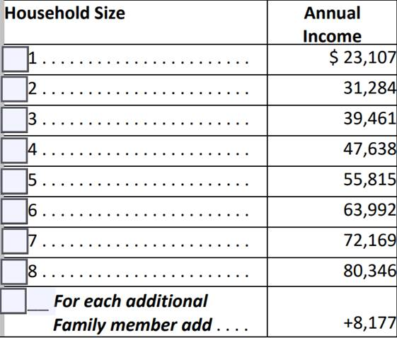

The District’s retention of the information table provided by the private school is sufficient to demonstrate the low-income student identification to future monitors. Upload to MCAPS LEA Document Library, into the subfolder for ESSER Equitable Services Plan.

1. **Private school affirmation/signature for new ESSER equitable services plan**

The District will provide a new ESSER Equitable Services Plan to the private school with the correct amount of equitable share shown in Box 1, and any alterations to noted services. The private school administrator will mark the secular/neutral/nonideological affirmation, the Agree or Disagree field, and sign and return.

The District will upload to MCAPS LEA Document Library, into the subfolder for ESSER Equitable Services Plan.