

MSIS USER MANUAL

Office of Federal Programs

Revised July 2020

TABLE OF CONTENTS

INTRODUCTION…………………………………………………………………………………………………………………………………………………. 3

ACCREDITATION STANDARDS 4

ACCESSING MSIS 7

FEDERAL PROGRAMS PERSONNEL 13

COURSE WORK AREA CODES REPORT 14

DESCRIPTION 15

Verifying Course Codes 16

Verifying Endorsement Area Codes 18

PERSONNEL REPORTS 19

SPECIAL PROGRAM CODES 20

SPECIAL PROGRAM CODES (CONT’D) 21

SCHOOL INDICATORS 22

STUDENT INDICATORS 23

STUDENT INDICATOR REPORT 24

HOMELESS 25

HOMELESS REPORT #1 31

HOMELESS REPORT #2 32

RESIDENCY VERIFICATION FORM (SAMPLE) 35

LIMITED ENGLISH PROFICIENT/ENGLISH LANGUAGE LEARNER 36

HOME LANGUAGE SURVEY* 46

IMMIGRANT 47

IMMIGRANT REPORT 49

MIGRANT 52

MIGRANT REPORT 53

NEGLECTED OR DELINQUENT 54

NEGLECTED OR DELINQUENT REPORT #1 55

Neglected or Delinquent Report #2 57

FEDERAL PROGRAMS REPORT 59

MSIS DISTRICT TIMELINE 61

GLOSSARY 65

REPORT GLOSSARY 67

**Introduction:**

The Office of Federal Programs’ MSIS User Manual assists Coordinators with providing the Mississippi Department of Education with complete, accurate and timely data.

MS Student Information System(MSIS) provides for the electronic collection and storage of comprehensive detailed data about teachers, administrators, students (Pre-K to 12) and school board members. MSIS also allows for the electronic transfer of student records from one school district to another, thus offering a unique student tracking system. The purpose of MSIS is to provide an efficient means in which to:

* Support the Mississippi Department of Education (MDE) performance-based accreditation model
* Support education funding programs
* Provide timely and accurate reporting of education data (schedules, attendance, grades, transportation, discipline, Vocational and Special Education) to meet state and federal requirements
* Allow for student tracking across the state to determine student mobility trends and to assist in the reduction of the drop-out rate within the state

This user manual provides a more detailed step by step approach where program coordinators can use MSIS to update, validate and report data more accurately and timely.

# Accreditation Standards

***2.1 ASSIGNMENT OF DISTRICT ACCREDITATION STATUS***

In the fall of each year, the CSA determines the annual accreditation status of all public school districts based on verified accreditation data from the previous school year. An annual district accreditation status is assigned based on compliance with Process Standards. Information concerning district compliance with Process Standards is reported to the CSA on an annual basis. See Policy 2.2.

The district superintendent and school principals are responsible for ensuring that all data reported to the MDE are true and accurate as verified by supporting documentation on file in the school district. Reporting false information is a violation of the accreditation requirements set forth by the SBE and may result in the downgrading of the district's accreditation status.

After the CSA acts on accreditation records presented, during the fall, the district superintendent and the chairperson of the local school board are notified of the assigned status. The decision of the CSA is final unless appealed by the school board of the school district to the SBE in accordance with the appeal procedures in Policy 6.0 of this document. If a school board of the school district does not request a hearing before the CSA, they waive their right to any appeal of the CSA’s decision.

***2.9.4 PENALTY FOR THE WITHDRAWAL OF ACCREDITATION***

Policy 2.9.3 is effective one (1) calendar year following the Withdrawal of Accreditation by the CSA and the SBE.

The withdrawal of a school district’s accreditation by the CSA will result in the following:

• A school or schools within a district shall be limited to participation in no more than fifty

percent (50%) of the regular season of any interscholastic activity, which shall include

division/district/regional games,

• The interscholastic season schedule for a school or schools within a district shall not

include the opening day of season or any type of post season participation, as determined

by the Office of Accreditation, and

• Cheerleading, drill and dance squads, speech and debate, choral music, and band may

participate in district or state contest, but shall not be eligible to receive ratings.

All schedule requests must be submitted in writing to the MDE’s, Office of Accreditation, at least thirty (30) days prior to the beginning of the season. The Office of Accreditation shall pre-approve all schedules and participation in interscholastic activities. In addition to the suspension of all post season activities, the school district shall not be allowed to participate in jamborees, special games, parades, tournaments, holiday tournaments, or competitions of any nature.

Failure to comply with section 2.9.3 will result in the suspension of ALL interscholastic activities.

Failure of a district to have its accreditation reinstated by the CSA after a period of two (2) calendar years from the date of the withdrawal of accreditation shall result in the immediate suspension of ALL interscholastic activities until the district’s accreditation status is reinstated.

Note: Interscholastic activities include, but are not limited to, football, basketball, baseball, track and field, cross country, tennis, golf, volleyball, softball (fast pitch and slow pitch), soccer, wrestling, swimming, power lifting, bowling, archery, cheerleading, drill, and dance squads, speech and debate, choral music, and band.

**PROCESS STANDARDS**

***ADMINISTRATION AND PERSONNEL***

1. The local school board and the superintendent of schools shall exercise due diligence in performing the respective duties of each office in accordance with applicable law. The local school board’s responsibilities shall pertain to matters of setting policy and shall not interfere in the day-to-day operations of the school district that include, but are not limited to, such duties as those relating to personnel and management decisions. Failure to comply shall result in the immediate downgrade of the district’s accreditation status to Probation or Withdrawn as indicated in Accreditation Policy 2.5. Miss. Code Ann. §§ 25-41-1 et al.; § 25-61- 1 through 17; § 37-3-4(5); §§ 37-6-7, 9, 11, and 15; §37-7-306(1-4); §§ 37-9-1 through 75; §§ 37-9-101 through 113; §37-7-301(p)(w); § 37-6-3(3-4); § 37-9-7, 13, 14; § 37-61-9; § 37-151-5(h); and Federal Civil Rights Act of 1964.

1.1 The school board assigns all executive and administrative duties to the superintendent, who is properly licensed and chosen in the manner prescribed by law. Miss. Code Ann. § 37-6-3(3-4); § 37- 9-7, 13, 14; § 37-61-9; and § 37-151-5(h).

1.2 School board policies that comply with state and federal statutes, rules, and regulations serve as the basis of operation for the district, and current copies (print or electronic) of school board policies are published and available for public review. Miss. Code Ann. § 25-41-7; §§ 25-61-1 through 17; §§ 37- 9-1 through 75; §§ 37-9-101 through 113; § 37-7-301(p)(w); and Federal Civil Rights Act of 1964.

1.3 School board members complete required basic and continuing education programs in order to effectively perform their duties in the manner prescribed by law. Miss. Code Ann. §§ 25-41-1 et. al; §§ 25-61-1 through 17; § 37-3-4(5); § 37-6-7, 9, 11, and 15; and § 37-7-306(1-4).

1. All district professional positions requiring licensed staff are filled by staff that are properly licensed and endorsed as required by state law and federal requirements of the Elementary and Secondary Education Act (ESEA). Miss. Code Ann. § 37-9-7 7, Miss. Admin. Code 7-3: 80.1 and 80.2. State Board Policy Chapter 80, Rules 80.1 and 80.2, and ESEA, and Federal Code.

2.1 The school district employs an appropriately licensed full-time principal at each school. The principal may not have any other job duties assigned in areas that require a specific work area code unless a waiver is granted by the Commission on School Accreditation. This standard does not apply to assistant principals. Miss. Code Ann. § 37-9-7, § 37-9-15, and § 37-151-5(g).

2.2 With the exception of academic core subjects, the professional staff in each school is comprised of no more than 5% of Full Time Equivalent (FTE) units working outside the area or areas of endorsement. Assistant principals and administrative interns who are not properly endorsed may be included in the 5% FTE working outside their area of endorsement, provided they do not act in the place of the principal. An appropriate license is required for superintendents, principals, librarians, and guidance counselors.

2.3 The school district employs in each school a licensed librarian or media specialist who devotes no more than one-fourth (¼) of the workday to library/media administrative activities. Miss. Code Ann. § 37- 17-6(3) (a-e).

2.3.1 If the student enrollment is 499 or less, a half-time licensed librarian or media specialist is required.

2.3.2 If the student enrollment is 500 or more, a full-time licensed librarian or media specialist is required.

2.4 Student support services (appraisal, academic, and/or personal advisement, and educational and/or career planning and referral) are provided in each school by qualified student support personnel. Student support personnel may only provide those services and activities in the area(s) that each individual is specifically qualified to provide and will use only job titles that reflect same. Miss. Code Ann. § 37-9-79. 19

2.5 The school district employs a school business officer/administrator whose qualifications meet the criteria established by the Mississippi Department of Education and whose primary job responsibilities are conducting, supervising, and/or directing the financial affairs and operations of the school district. (Miss. Admin. Code 7-3: 71.1 and 71.2, State Board Policy Chapter 71, Rules 71.1 and 71.2.

3. The school district implements an annual, formal personnel appraisal system for licensed staff that includes assessment of employee on-the-job performance. Miss. Code Ann. § 37-3-46(b)

3.1 Superintendent Evaluation using the assessment benchmarks established by the Mississippi School Boards Association (MSBA) and consistent with assessment components defined in Miss. Code Ann. § 37-7-301.

3.2 Principal and Assistant Principal Effectiveness using the Professional Growth System (PGS) for Administrators.

3.3 Teacher Effectiveness using the Professional Growth System (PGS) for Teachers.

3.4 Counselor Effectiveness using the Professional Growth System (PGS) for Counselors.

3.5 Annual employee performance data shall be submitted to the MDE following the guidelines in the MDE Educator and Administrator Professional Growth System Guidelines. Districts shall adhere to revision dates as determined by the MDE and implement only the current version.

3.6 Administrators who rate school-level administrators, counselors, librarians, and teachers, and teacher-observers shall complete an MDE-approved Professional Growth System (PGS) training.

3.7 Other, non-licensed, district staff evaluations as determined by local school board policy.

4. The local school board obtains an annual financial audit of the school district, as conducted under the guidelines of the Office of the State Auditor, no later than nine months after the end of the district’s fiscal year. Miss. Code Ann. § 7-7-211(e) (Miss. Admin. Code 7- 3: 10.1, State Board Policy Chapter 10, Rule 10.1. 2 C.F.R. Part 200.

4.1 The most recent annual financial audit report of the school district, as conducted under the guidelines of the Office of the State Auditor, indicates a fixed asset system of accountability that provides verification of fixed assets and fixed assets records. Miss. Code Ann. § 37-17-6(18).

4.2 The most recent annual financial audit report of the school district, as conducted under the guidelines of the Office of the State Auditor, indicates no less than a zero fund balance (as defined by generally accepted accounting principles) for all funds of the school district. Miss. Code Ann. § 37-61-19.

4.3 The most recent annual financial audit report of the school district, as conducted under the guidelines of the Office of the State Auditor, verifies the process for distributing Educational Enhancement Fund procurement cards to all eligible teachers. Miss. Code Ann. § 37-61-33(3)(iii), Miss. Admin. Code 7-3: 32.1, State Board Policy Chapter 32, Rule 32.1.

4.4 The most recent annual financial audit report of the school district, as conducted under the guidelines of the Office of the State Auditor, indicates an unqualified opinion (as defined by generally accepted auditing standards) on the financial statements of the school district. Miss. Code Ann. § 37-9-18(2) and § 37-61-29.

4.5 The most recent annual financial audit report of the school district, as conducted under the guidelines of the Office of the State Auditor, verifies the local school board has received, reviewed and discussed, as reflected in official minutes of the regularly scheduled monthly meeting, the financial reports required by state law and/or the State Board of Education. Miss. Code Ann. § 37-9-18(1), § 37-37- 7(2)(e), § 37-37-13, Miss. Admin. Code 7-3: 71.3, State Board Policy Chapter 71, Rules 71.3.

4.6 The most recent annual financial audit report of the school district, as conducted under the guidelines of the Office of the State Auditor, verifies the accuracy and timely compilation and reporting of all financial data, including the year-end data provided through the Financial Exchange Transfer System (FETS), required for submission to the MS Department of Education by the fifteenth day of October, each year, in accordance with state law and/or the State Board of Education. Miss. Code Ann. § 37-37- 7(2)(e), § 37-61-21(2), and § 37-37-13. 20

4.7 The most recent annual financial data of the school district, as submitted to the MS Department of Education, verifies a 7% fund balance of the district maintenance fund. Miss. Code Ann. § 37-61-8.

5. The most recent annual financial audit report of the school district, as conducted under the guidelines of the Office of the State Auditor, verifies the following:

5.1 The local school board submits the annual budget to the levying authority and the prescribed budgetary information to the MS Department of Education by the fifteenth day of August, each year, in accordance with state law and/or the State Board of Education. Miss. Code Ann. § 37-61-9(1) through (3).

5.2 The local school board budgets and expends funds under the Public School Health Insurance Plan as required by state law and State Board policy. Failure to remit premiums, interest penalties, and/or late charges in a timely manner may result in withholding a school district’s adequate education program funds Miss. Code Ann. § 37-151-95, Miss. Admin. Code 7-3: 48.4, State Board Policy Chapter 48, Rule 48.4.

# ACCESSING MSIS

MSIS can be accessed in different ways:

1. Go to the MDE web site, <http://www.mdek12.org> , and under Educators tab, Administrators tab or Services tab, click on the MSIS (MS Student Information System). You will be taken to the MSIS web page. Click on the Links section; “MSIS Log-on” under Applications.

2. Go to the MSIS Information web page, <http://www.mdek12.org/OTSS/MSIS> , and then click on the Links section; “MSIS Log-on” under Applications

If you choose option 2 by going to the MSIS Information web page

http://www.mdek12.org/OTSS/MSIS, and then click on the Links section;

“MSIS Log-on” under Applications.

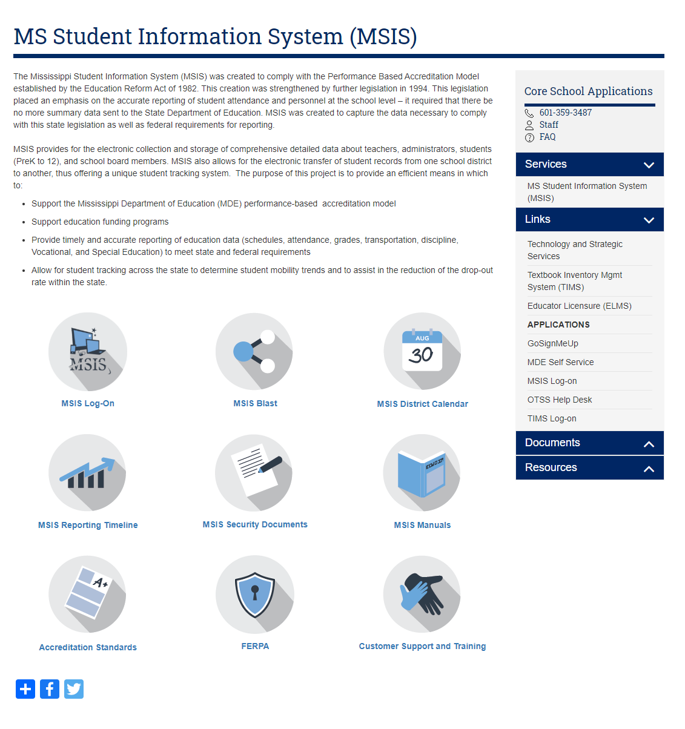

# Once you get to the MSIS logon box shown below, you will need to enter your MSIS logon credentials and click connect.

# 

# Username – Your MSIS Primary Contact will be able to assist you with this.

# Password – Your MSIS Primary Contact will be able to assist you with this.

# Database – always enter *msis*

# Once connected the window below is displayed. You have now logged into MSIS.

# 

# 

# 

***NOTE:*** Do not open multiple MSIS windows at one time – *known as* ***Stacking*** - this will lock or slow down the computer or possibly disable functions on other screens.

# PASSWORDS

# Always make sure that you close the browser when you leave your computer. Never let the computer remember the password for you. Never put the password on a sticky note on your computer. And NEVER share your password with anyone else.

# You can change your password in MSIS at any time. Just go to *Security*, *Change User Password*. You can only change the Password for your Login Name.

# 

# 

# On the Change Password screen, enter your old password, then your new password, re-enter the new password and click on OK. You should logout and log back in to be sure the new password works.

# 

# The Password must be at least 8 characters and not longer than 30 characters. The Password must contain at least one non-alpha character. The new password must be at least two characters different from the old password. Passwords will expire 60 days from the date of a change. Passwords not changed 30 days after date of expiration will be locked. Please contact your MSIS Primary Contact or MSIS Secondary Contact. They will be able to unlock a locked account. Any account will be locked after three failed login attempts and the user will have to contact the MSIS Primary Contact or MSIS Secondary Contact to unlock the account.

# The Password Reset Policy is: User contacts their district’s MSIS Primary or MSIS Secondary Contacts. MSIS Primary or MSIS Secondary Contact should contact the OTSS Help Desk at mdeapps@mdek12.org to reset password by emailing the name and last 4 digits of the user SSN that needs their password reset.

# MSIS sessions will be logged out after 30 minutes of inactivity. A session where a “save” hasn’t been executed or a screen change hasn’t occurred is considered an inactive session. A session where a report is running is NOT considered an inactive session. If you are entering data but haven’t saved within the last 30 minutes then your session will be considered inactive. You won’t know the session is inactive until you try to save the data, so it is important to save regularly.

**User Access Levels**

There are specific levels granted to users either as District or School. Federal Programs Directors have access to District level information and any other access rights granted by the district MSIS Primary or Secondary Contact.

**MSIS 2 Form and Oath of Confidentiality**

Before access to MSIS is granted each user must have signed security documents on file.

MSIS Security Documents are located on the MSIS website: visit our website at <https://www.mdek12.org/OTSS/MSIS>, click on MSIS Security Documents to access the security forms.

**MSIS Blast** is an email used to communicate with school districts regarding MSIS changes and updates. Please subscribe by visiting <https://www.mdek12.org/OTSS/MSIS> and clicking on MSIS Blast.



# Federal Programs Personnel

The federal programs director provides accurate information on salaried personnel to the MSIS Primary or designated MSIS personnel employee to input employees paid with title program funds into the SAP and MSIS.

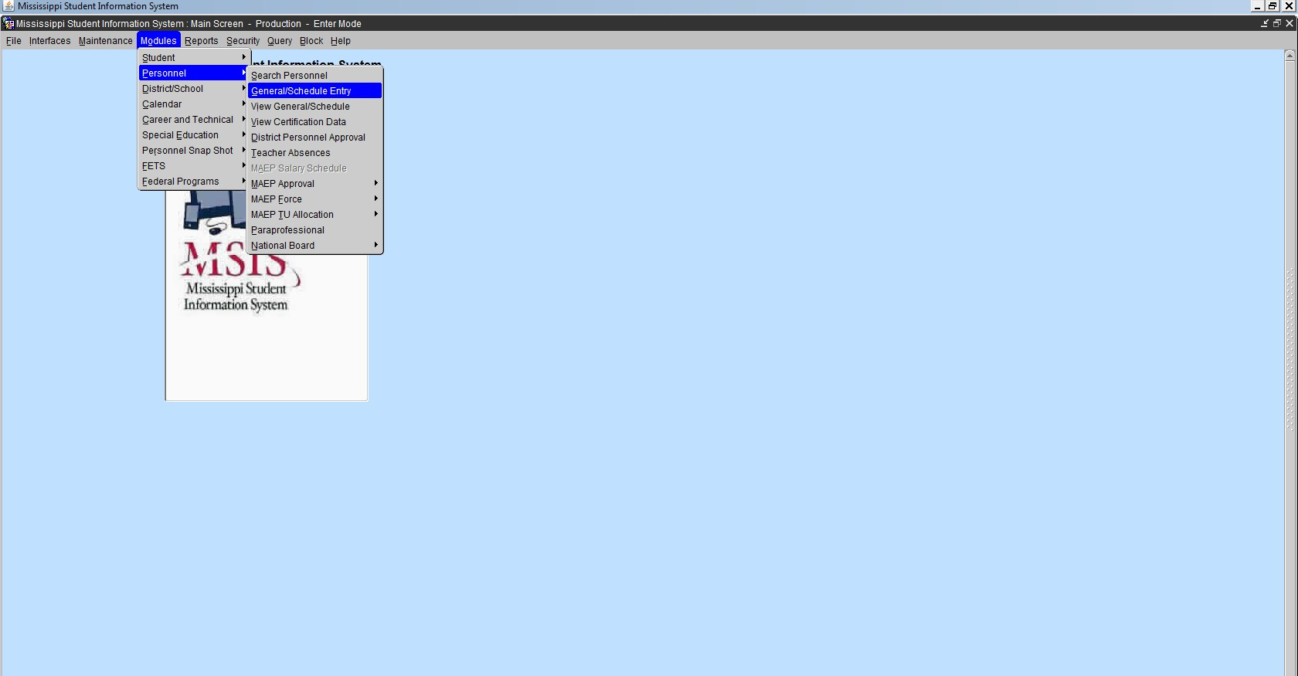

**Federal Personnel**

Federal personnel must be marked appropriately in MSIS.

1. Select only course code(s) in which staff is properly certified.

If not a licensed staff, please select the proper course code for the duties performed.

1. Select only the special program code assigned to the course code.

Special program code is the number assigned to a course code for salaries of employees.

* 1. Title 1 Special Program Code “1”
  2. Other Title special program code “9”

1. Reserved Field Code (SW): Title 1 Schoolwide

Use **SW** code in the Reserved field when a School-wide Program is approved for Title I funding and a course is being taught that will not allow a “1” for Title I funding.

**Never** put both a “1” and “SW” in the same period.

United States Department of Education (USDoE) requires the data reported to answer the following questions:

* + - Which subject area teachers and paraprofessionals are paid by what federal program?
    - Are teachers and paraprofessionals paid by federal funds meeting the Highly Qualified requirement?

The data is being captured in a data warehouse, where the information will be available to the public, and increase transparency in government programs and spending.

**Best practice recommends:** Keep a copy of the personnel report for federal funded staff for unscheduled audits and future monitoring.

For a copy of the MSIS Personnel Manual: visit <https://www.mdek12.org/OTSS/MSIS> and click on MSIS Manuals.

**NOTE:** All district personnel must be entered in MSIS Personnel and approved **on or before September 30.**

Employee entries and edits are allowed **until December 9. MSIS Personnel CLOSED December 10.**

# Course Work Area Codes Report

A Course Work Area Codes Report must be used in selecting the proper course codes for a federal program employment title. The report may be printed and/or saved to the desktop for future reference.

Login **MSIS, Reports, District, Course Work Area Codes**

***Note:*** *Report appears in PDF. If the report does not appear – Turn off Pop-Up-Blocker or click Allow Pop ups from this site.*

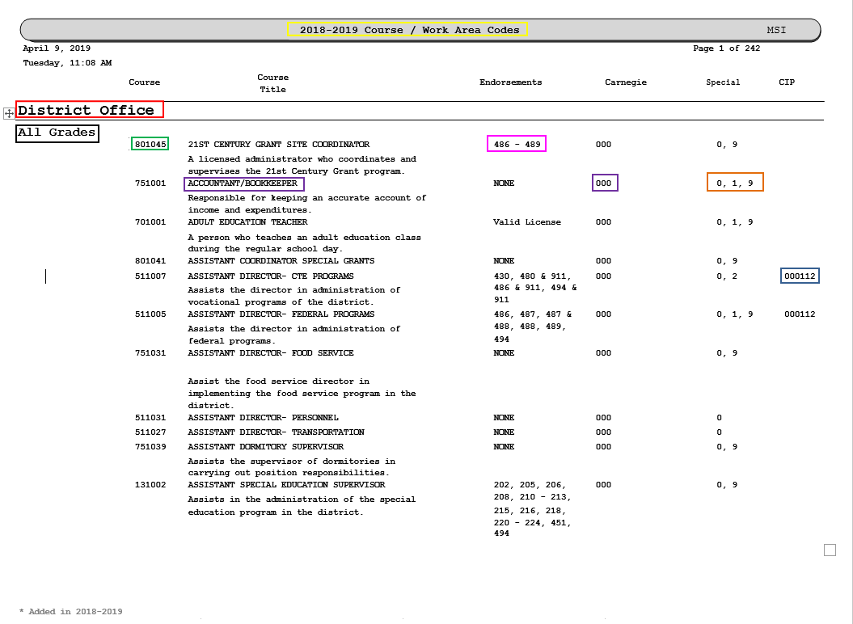

# Description:

Current School year – The manual is updated every school year and the previous year manual is no longer available via MSIS. The report displays active course codes for the school year.

District Office – is the work area in the district in which the course is assigned in MSIS Course – code attached to a job title at every level of the district

All Grades – identified grade level assigned to a course code. This may also indicate a particular area at the school level.

– job title with or without brief qualifications listed

Course Title

Endorsements – a code of certification required to obtain particular employment.

**Note:** Various licensed positions require two or more endorsements to occupy the job title.

The **& (and)** symbol that separates the endorsement codes defines that the employee must be certified with both endorsements listed with the course code.

**e.g. 486 & 488**

Carnegie - The number of units assigned to a subject area course code. The units assigned are based on the subject area course being taught at a minimum of 9 weeks up to a full academic school year.

Special - the program code(s) from which the salary is paid for each course code.

CIP (Classification of Instructional Programs) – code developed by USDoE to track Career and Technical Education programs on a national level. This code is only used with CTE course codes.

Once federal personnel has been selected and entered in MSIS, request a copy of the **Accreditation Edit Report** from the MSIS Personnel designee assigned in the district. This report will indicate any errors that exist with federal personnel per course code.

# Verifying Course Codes

Enter *MSIS, Maintenance, Course Code*

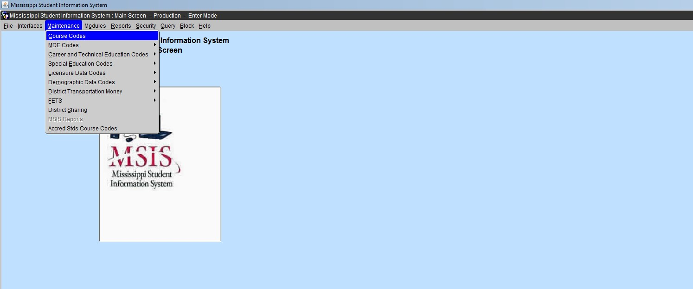

Scroll to find the desired course code or course name or click the flashlight to clear the screen. Enter the course code number and click the flashlight or tab to the right to enter the first three letters of the course name with the percent sign (%) and click the flashlight. The information will appear.

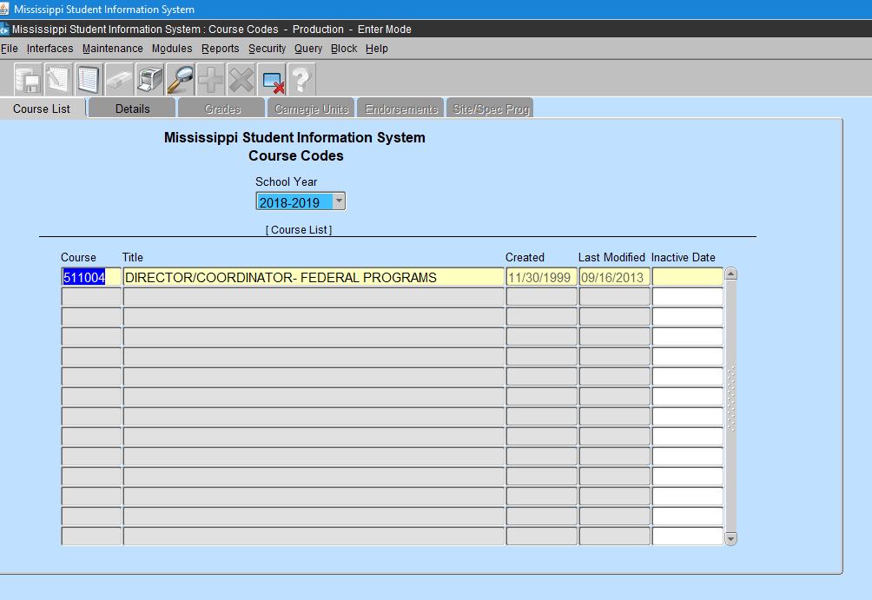

After selecting a course code - **Click the Details Tab** – all other tabs appear in black

Each tab provides information about the selected course code

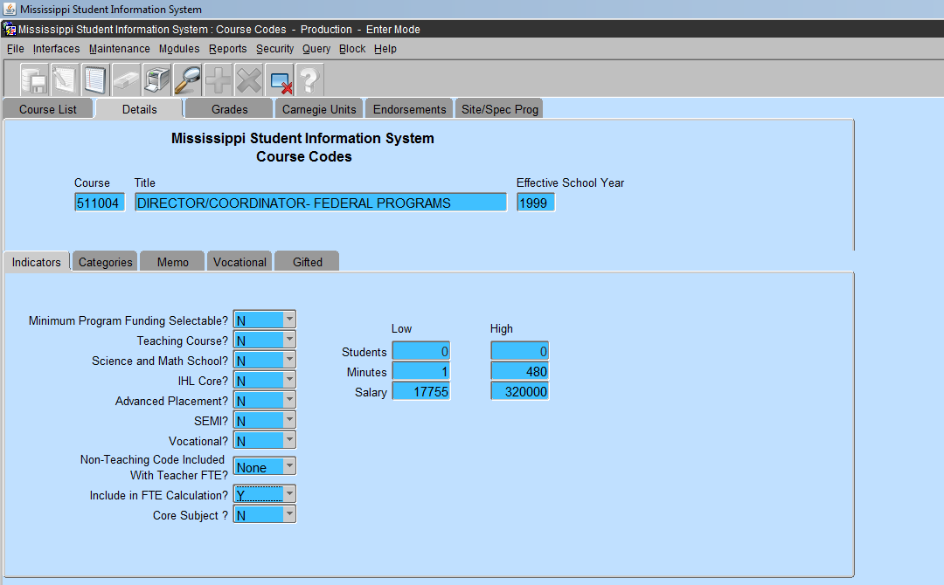

Each tab listed provides information pertaining to the selected course code. Please click each tab to view the information before assigning the course code to an employee. The **employee must be licensed** in the assigned endorsements selected on the endorsements screen. If an employee **is not licensed** in the endorsement(s) assigned to the course code, it will result in a error on the Accreditation Edit Report.

Any errors that exist on the report must be corrected **before** December 10 or it will result in a violation of an Accreditation Standard. The error(s) will be addressed via letter acknowledging the district error(s). If not corrected by the date assigned on the letter, the district is subject to a possible downgrade in its accreditation standards.

Please contact the Office of Accreditation for more information.

# Verifying Endorsement Area Codes

Enter MSIS, Maintenance, MDE Codes, Endorsement Area Codes

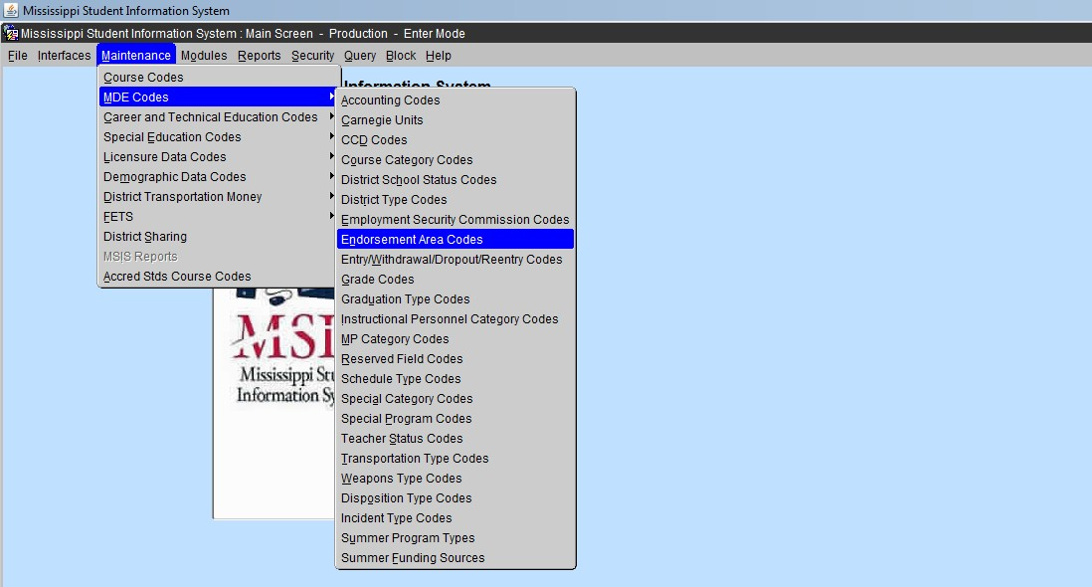

The screen will appear with all endorsement area codes assigned by the Office of Educator Licensure.

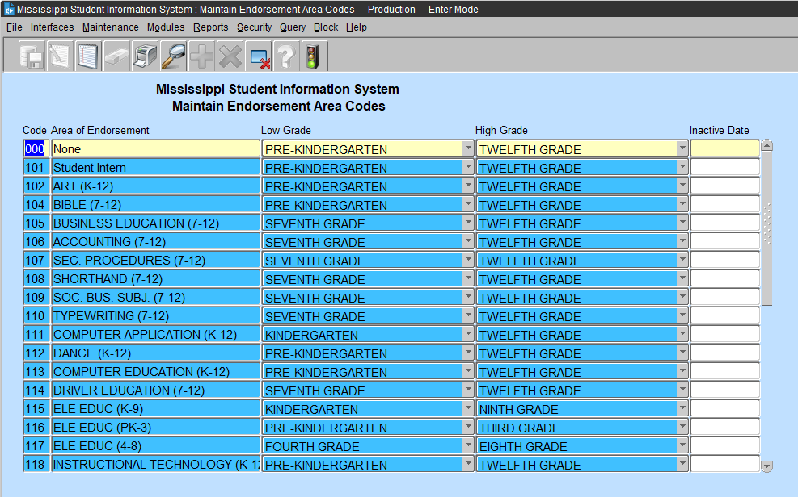

Course codes may or may not have endorsement area code assigned. The potential employee must have the proper endorsement codes listed on a **valid** MS issued educators license before obtaining employment in the district and/or school.

Detailed information about the endorsement area code can be found in the course code section in MSIS.

# Personnel Reports

Enter MSIS, Reports, Personnel Data, **Detailed Personnel Listing**

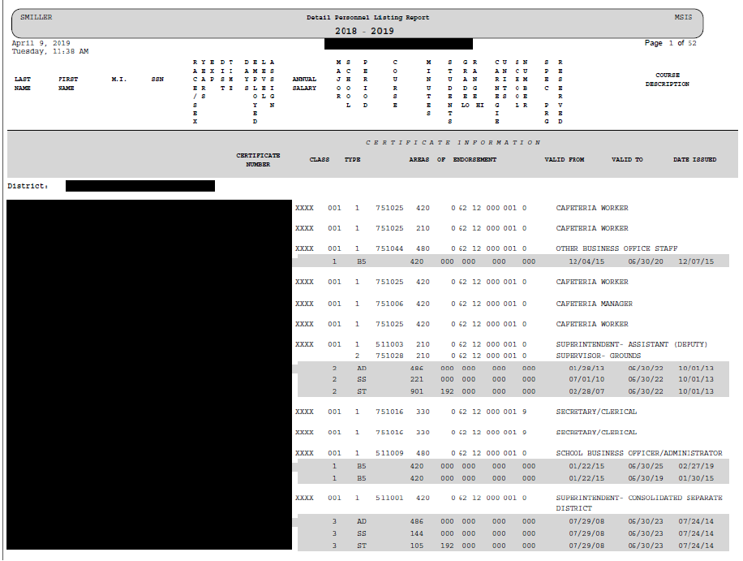  
This report provides limited details of the employees in the district.

MSIS, Reports, Personnel Data, **General Schedule Listing**

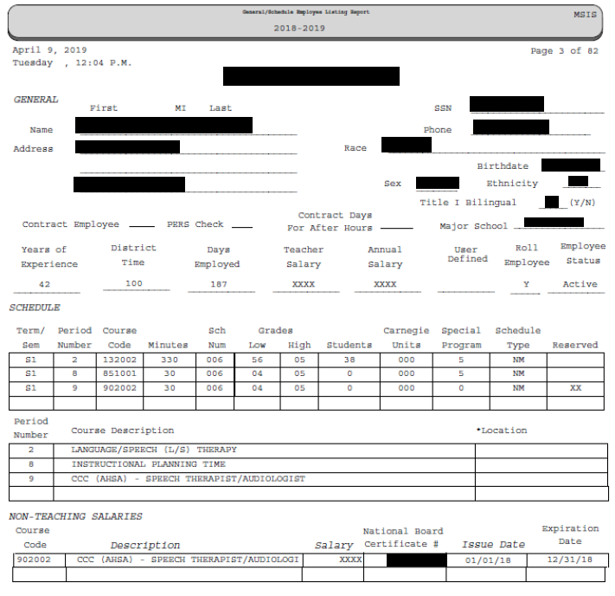

This report provides accurate detailing of an employee. It displays location (school number), term and period, minutes, course codes assigned to the employee, grade level, number of students along with Carnegie unit (class credits) and special program code (salary payment). It also lists other course codes that are non-teaching codes assigned to the employee.

# Special Program Codes

**Enter MSIS, Maintenance, MDE Codes, Special Program Codes**

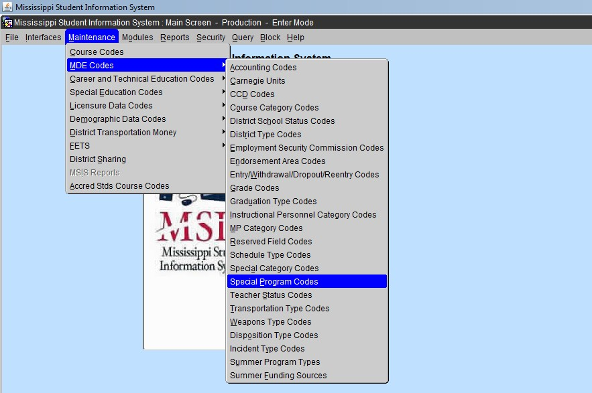

The special program codes are used to determine the salary payment method for a course code assigned to personnel employed at the district and school level.

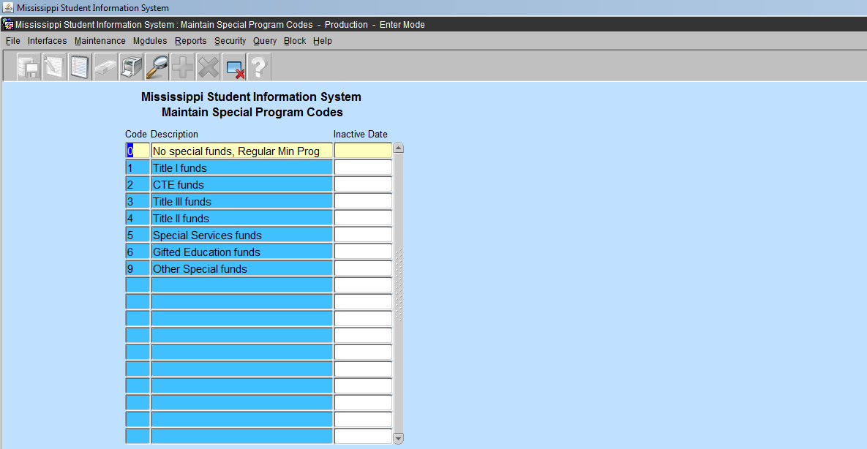

# Special Program Codes (cont’d)

**Title I Funds (1) are used to pay the salaries of teachers and paraprofessionals** must be used primarily for direct instructional services for students. Teachers and/or assistants (paraprofessionals) should be appropriate designated according to subject areas (reading

/writing/math, ESL–Language Instruction Program, etc.) with specific position titles listed. Ensure that Title I staff provide direct, but supplemental, instructional services for students. Staff should only appear for academic areas, not physical education. However, a parent liaison or parent coordinator may be funded.

**Title II Funds (4) are used to pay the salaries of highly qualified teachers** for the purpose of reducing class size. In addition, as reasonable and necessary, Title II, Part A funds may be used to pay for substitute teachers if, and only if, (a) those regular classroom teachers they are replacing were hired with Title II, Part A funds to reduce class size, or (b) the teachers are participating in Title II-funded “programs and activities that are designed to improve the quality of the teacher force, such as…innovative professional development programs…” [Section 2123(a)(5)(A)].

LEA’s also must ensure that the hiring of these substitutes’ supplements, and does not supplant, the use of local and State funds they would otherwise be spending for such substitutes.

**Title III Funds (3) are used: (1)** To pay the salaries of before and after school tutors and academic assistance. **(2)** To employ bilingual/ESL coaches whose role is to acquire scientific- based research practices, provide professional development, mentor and coach teachers who are working directly with ELs. The funds can be used to provide stipends to teachers to assist them in completing and obtaining bilingual/ESL endorsements. Support for personnel, including paraprofessionals who have been specifically trained, or are being trained, to provide services to immigrant children and youth. Title III funds may NOT be used to pick up a cost that was previously funded by general funds **and may NOT supplant** any other federal, state or local expenses.

**Other Special Funds (9) are used to pay salaries:** Please refer to the specific federal programs (i.e., special education, 21st Century, etc.) guidelines to ensure that funding of teachers and paraprofessionals is an allowable expense.

# School Indicators

***ALL SCHOOLS*** must be properly identified before the submission of Month 1 Monthly Student Data (MSD) file on or before **September 30**.

# Login MSIS, Modules, District/School, School Demographics

The currently employed school district will appear in a box in the District tab.

**STOP** – if this box is blank or the information of a previous employed district appears. Contact the district MSIS Primary immediately.

Under the **School** tab, select a school in the district. Click the **Demographics** tab.

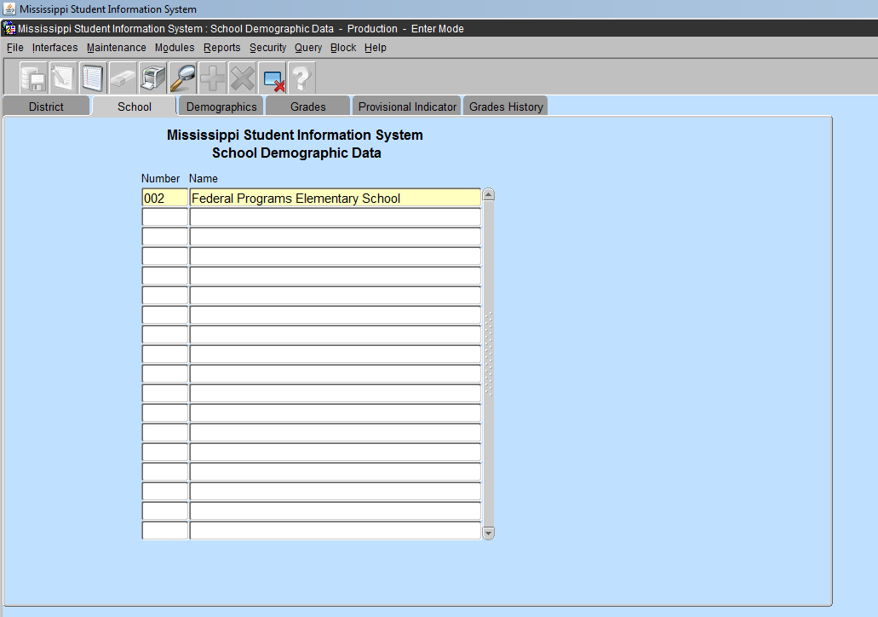

When the screen appears, at the bottom of the screen, select **Indicators** tab.

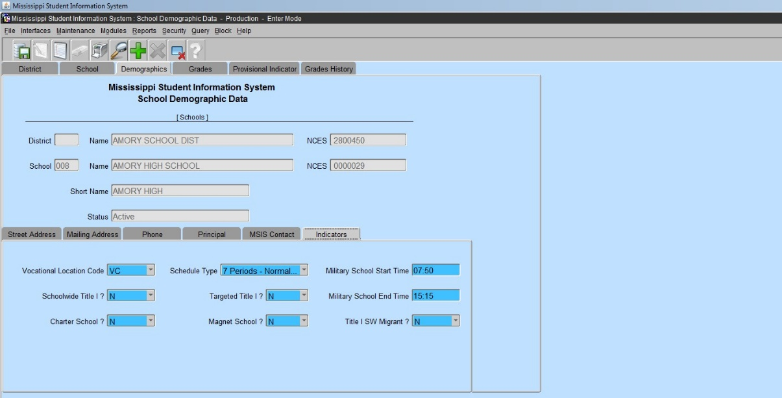

School Indicators are **Title I Schoolwide**, **Title I Targeted** and **Title I SW Migrant (must be “N”)**.

Whichever applies to the school selected it must display a **“Y”** or **“N”** in the box.

**Note:** Both boxes **must not** display a “Y”.

Click **SAVE** - green diskette or select File then select Save

Exit the screen – click **FILE, Exit**

# Student Indicators

***ALL STUDENTS*** must be properly identified in the SAP before the submission of Month 1, Monthly Student Data (MSD) file on or before **September 30**.

# Enter MSIS, Student, View Student Data

Student indicators are selected with a **“Y”** or **“N”** in the SAP. This is displayed in the View Student Data screen, Details tab.

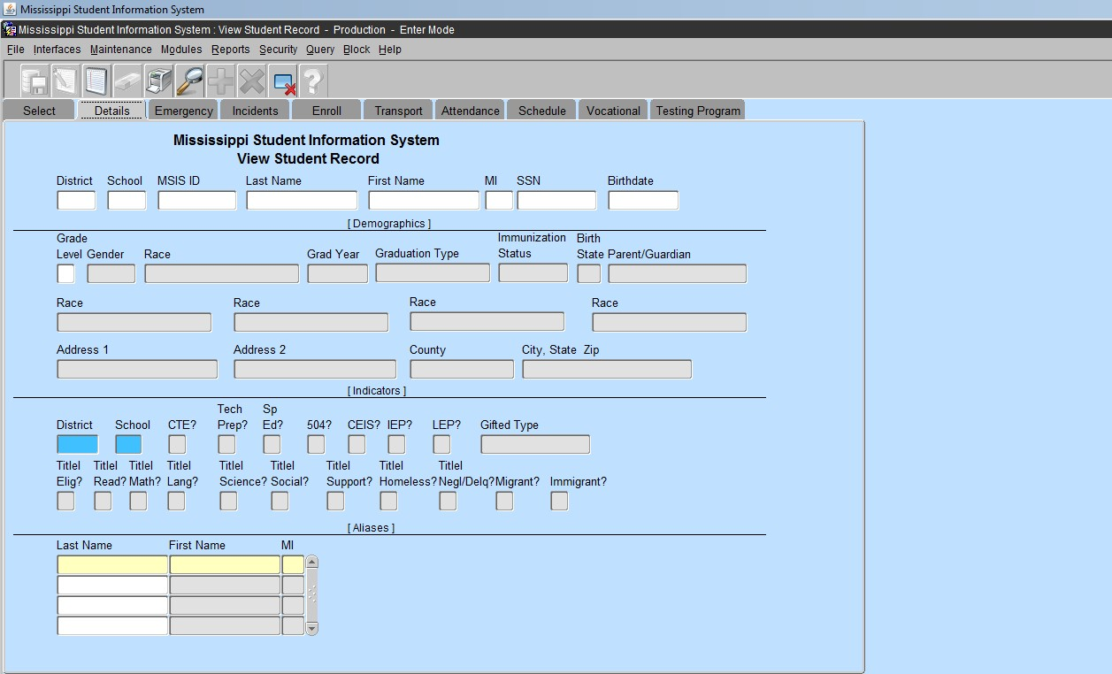

Student Indicators are selected in the SAP

Please refer to the **previous school year roster** of students identified and reported in a particular federal program.

New students that qualify begin with the student indicator in the SAP changed to **“Y” BEFORE** the submission of monthly student data that is submitted at the school level and approved by the district. The students will populate into the **federal program screens** and on reports **AFTER** the submission and approval of monthly student data to MSIS from the district.

If a student no longer qualifies for the program, print and provide a copy of the roster with each student identified to the school in which the student is enrolled and request to change the indicator to **“N”** in the SAP. This must be done **BEFORE** the submission of all monthly student data files at the school level and approved at the district level.

Once the indicator has been set to “N” the student screen will display the selection. When a student has been identified for a particular reason such as withdrawn, misidentified or a dropout, the student will not be counted for the entire month of the data submission. You **cannot remove** a student from the screen or the report.

**Note:** Schoolwide – all students enrolled receive Title I services. Targeted Assistance refers to particular students receiving the required services as identified according to the targeted assistance definition.

# Please refer to the definition of Targeted Assistance schools in the glossary to properly identify the students that qualify for the services.

# Student Indicator Report

**Enter MSIS, Reports, Student Data, Holding Area, Student Indicators**

Check an indicator or all indicators

***Note:*** A student can have more than one indicator selected to “**Y**”, if they qualify for the services. ***e.g.*** A student can be an Immigrant, SPED, Homeless and LEP.

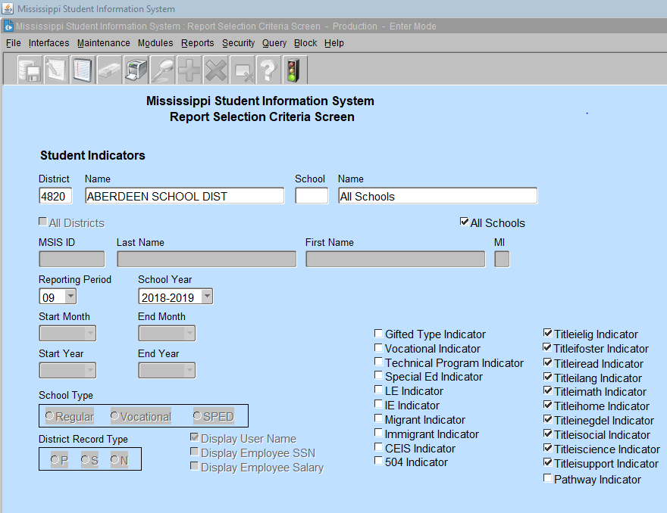

Click to Run Report

Click  to run report

**Note:** If a school in the district has been identified as Title I Schoolwide the number of students produced on this report is the total submitted to MSIS from the SAP at the school level. This report is created **after** the district has approved the MSD file submission. This report gives the total number of students enrolled and reported on a monthly basis. **This is extremely important for Month 1.**

***Note:*** *Report appears in PDF. If the report does not appear – Turn off Pop-Up-Blocker or Allow Pop- ups from this site.*

# Homeless

Select Modules, Federal Programs, Homeless

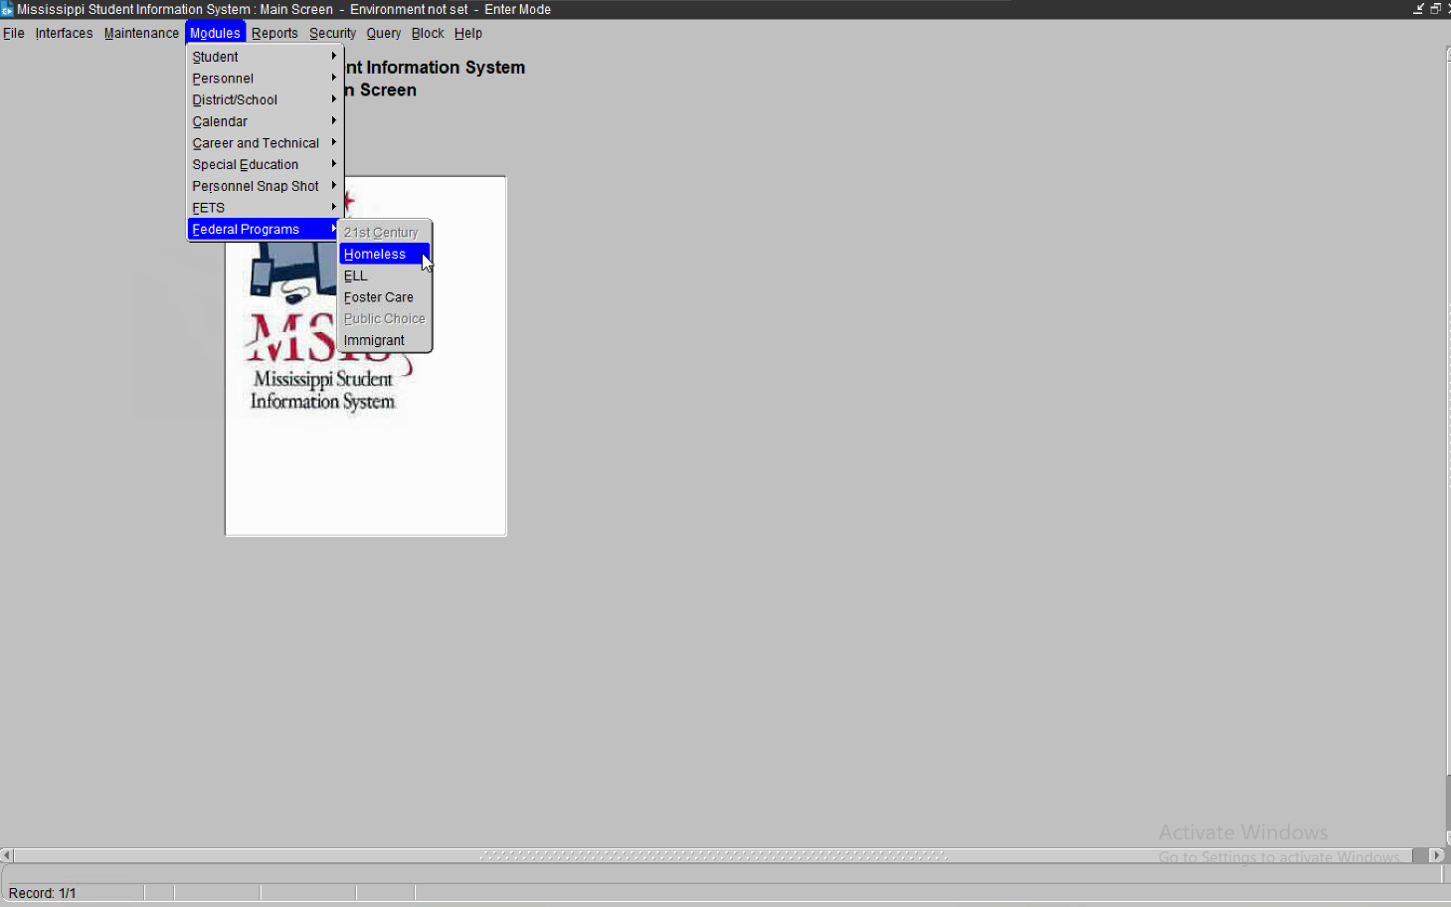

The indicator in SAP is selected as “Y” and the student’s information populates on the homeless screens **after** the district has approved the MSD file sent to MDE.

The student identification starts over in month 1 (by September 30).

Students identified as homeless or neglected/delinquent should be reset in SAP to “N” on the date after the district approves the end of year data (Month 9)

**\*\*\* Note on Homeless Students \*\*\***

Homeless Students: Please make sure that each of your Homeless students are marked as Title I Homeless in your student package for each month they are considered to be Homeless in order for them to appear in MSIS with the Homeless Indicator for those months.

**A Homeless Student** is a student: who lacks a fixed, regular, and adequate nighttime residence.

1. Children and youth who are sharing the housing of other persons due to loss of housing, economic hardship, or a similar reason; are living in motels, hotels, trailer parks, or camping grounds due to the lack of alternative adequate accommodations; are living in emergency or transitional shelters; or are abandoned in hospitals;
2. Children and youth who have a primary nighttime *residence* that is a public or private place not designed for or ordinarily used as a regular sleeping accommodation for human beings;
3. Children and youth who are living in cars, parks, public spaces, abandoned buildings, substandard housing, bus or train stations, or similar settings; and
4. Migratory children (as defined in section 1309 of the Elementary and Secondary Education Act (ESSA) of 1965, as amended) who qualify as homeless because they are living in circumstances described in this definition.

The permitted values to be selected in MSIS for primary nighttime resident are:

**Shelters -** transitional housing

**Doubled Up -** sharing the housing of other persons due to economic hardship, loss of housing or other reasons (such as domestic violence)

**Unsheltered -** includes cars, parks, campgrounds, temporary trailers including FEMA trailers, or abandoned buildings

**HM** – Hotels/motels

**Unaccompanied homeless youth -** includes a youth not in the physical custody of a parent or guardian.

# Definition of Homeless

The following definition, as provided, in the McKinney-Vento Homeless Assistance Act, must be used by the Local Education Agencies (LEAs) when determining the homeless status of a student. The term “homeless” includes children and youth who experience any of the following:

**Sharing the housing of other persons due to loss of housing, economic hardship, or a similar reason.** If economic hardship, such as an accident or illness, loss of employment, loss of public benefits, or condition of poverty, forces a family or youth to share the housing of others temporarily, the children and youth are eligible for McKinney-Vento services. Along-term, cooperative living arrangement among families or friends that is fixed, regular and adequate should not be considered a homeless situation, even if the parties are living together to save money.

**Living in a motel, hotel, trailer park, or camping ground due to the lack of alternative adequate accommodations.** Motels, hotels, and camping grounds will almost always be homeless situations, as they are rarely fixed, regular, and adequate residences. Asking questions about the condition and size of the trailer, the number of people living there, the intended length of stay, and whether the family or youth has an adequate alternative will help determine if the student is eligible for McKinney-Vento services.

**Living in an emergency or transitional shelter.** Emergency or transitional shelters of all kinds, including youth shelters, domestic violence shelters, family shelters, transitional living programs, and supportive housing programs are homeless situations.

**Abandoned in hospitals.** A child or youth abandoned in the hospital is eligible for McKinney- Vento services.

**Living in a public or private place not designed for or ordinarily used as a regular sleeping accommodation for human beings.** An example of a place that meets these criteria is a public restroom.

**Living in a car, park, public space, abandoned building, substandard housing, bus or train station, or similar setting.** In evaluation whether housing is “substandard,” consider that substandard means “deviating from or falling short of a standard or norm” or “of a quality lower than that prescribed by law.” Determining if housing is substandard requires comparing the housing with community norms and the law.

**Classified as migratory children who qualify as homeless for the purpose of this subtitle because the children are living in circumstances described above.** While migrant students are not categorically eligible for McKinney-Vento services, migrant students living in a primary nighttime residence that is not fixed, regular, and adequate are eligible.

# Select Modules, Federal Programs, Homeless

The school district in which you are currently employed will appear in a box in the District tab. **STOP** – if this box is blank or the information of a previous employed district appears, contact the district MSIS Primary immediately.

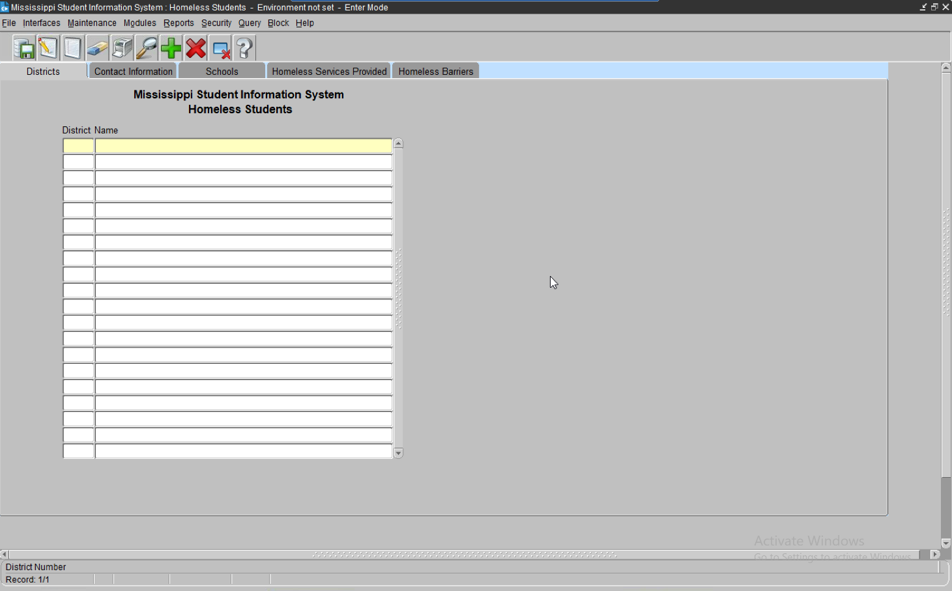

# Contact Information Tab

Please complete all sections of this screen. Click SAVE - 

The Federal Programs Director and Homeless Liaison information is required. Select the appropriate school year.

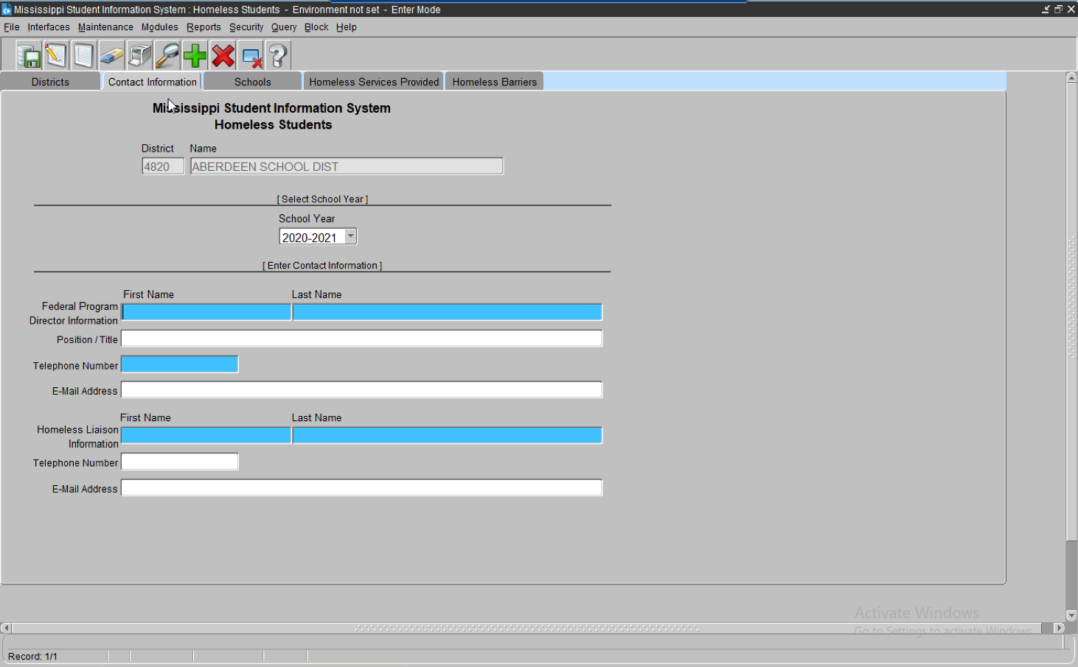

# School Tab

This tab displays all schools in the district. The highlighted line indicates the school being selected.

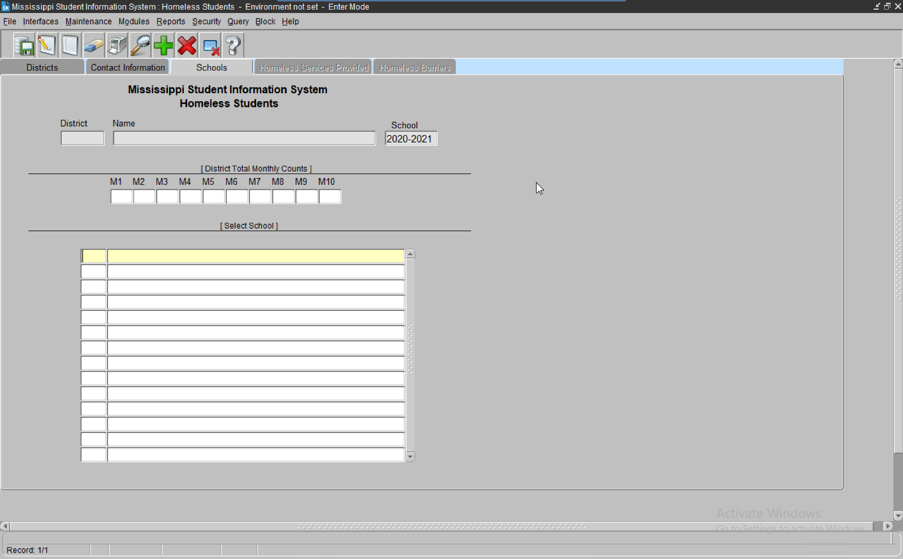

**District Total Monthly Counts -** are the number of students identified monthly in the SAP in the entire district as Homeless. Each qualifying student Homeless indicator in the SAP must be checked **“Y”** in the SAP.

The student counts are sent to MSIS from the SAP **after** the approval of the district Monthly Student Data (MSD) file has been submitted to MDE.

The data sent from the SAP produces a student roster that populates each student’s information on the Homeless Services Provided and Homeless Barriers tab.

# Homeless Services Tab

The indicator in the SAP is selected as “Y” and the student’s information populates on this screen

**AFTER** the district has approved the MSD file sent to MDE.

Select a service as it pertains to the student. Click save 

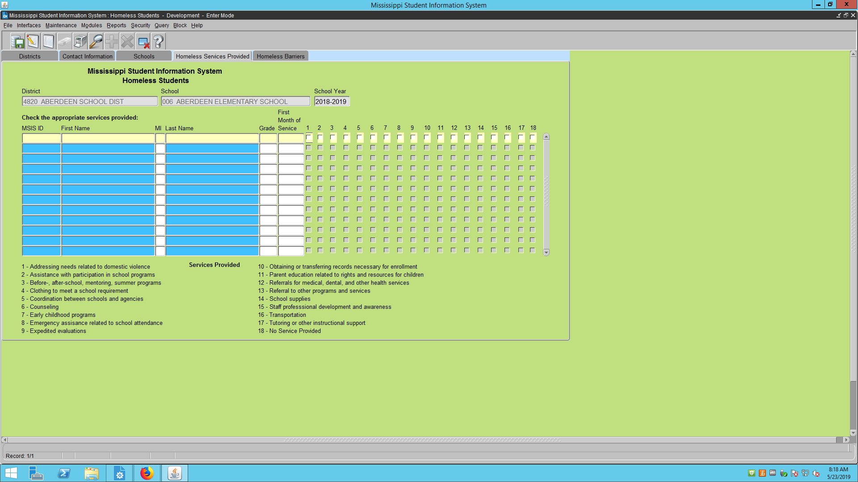

**First Month of Service** is the reporting month which the data was submitted to MSIS.

# Homeless Barrier Tab

***MANDATORY*** - All students must have a Living Condition selected – if they qualify as Homeless. A student can deny services but qualify as Homeless due to living conditions.

If a student has been **misidentified** – make no selections next to their name.

Unaccompanied homeless youth only refers to **homeless** students who are not in the physical custody of a parent or guardian.

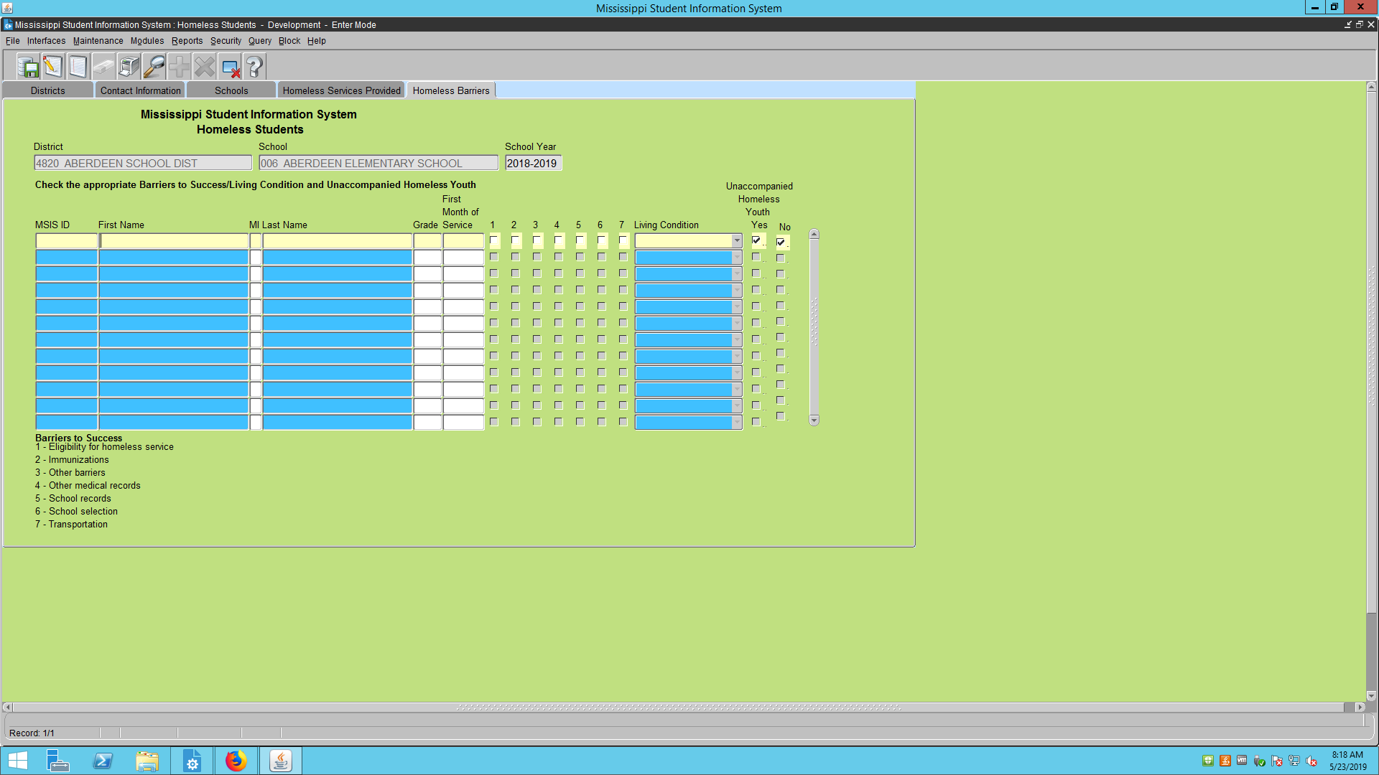

**Mandatory**

Please view **MONTHLY** to update student services if any changes have occurred or make the proper selections for new students that have been added from the SAP. Click SAVE -  Exit the screen – click **FILE then Exit**

# 

# Homeless Report #1

Enter MSIS, Reports, Federal Programs, Homeless

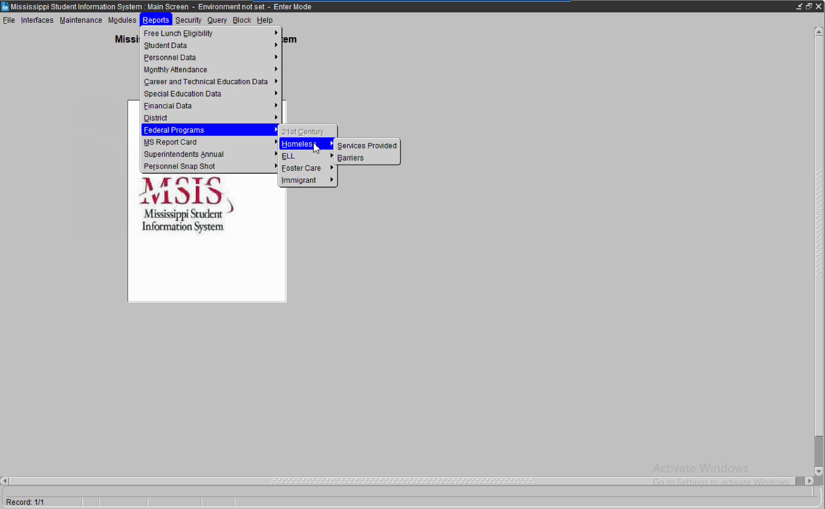

View the district and then select a school or check All Schools - click OK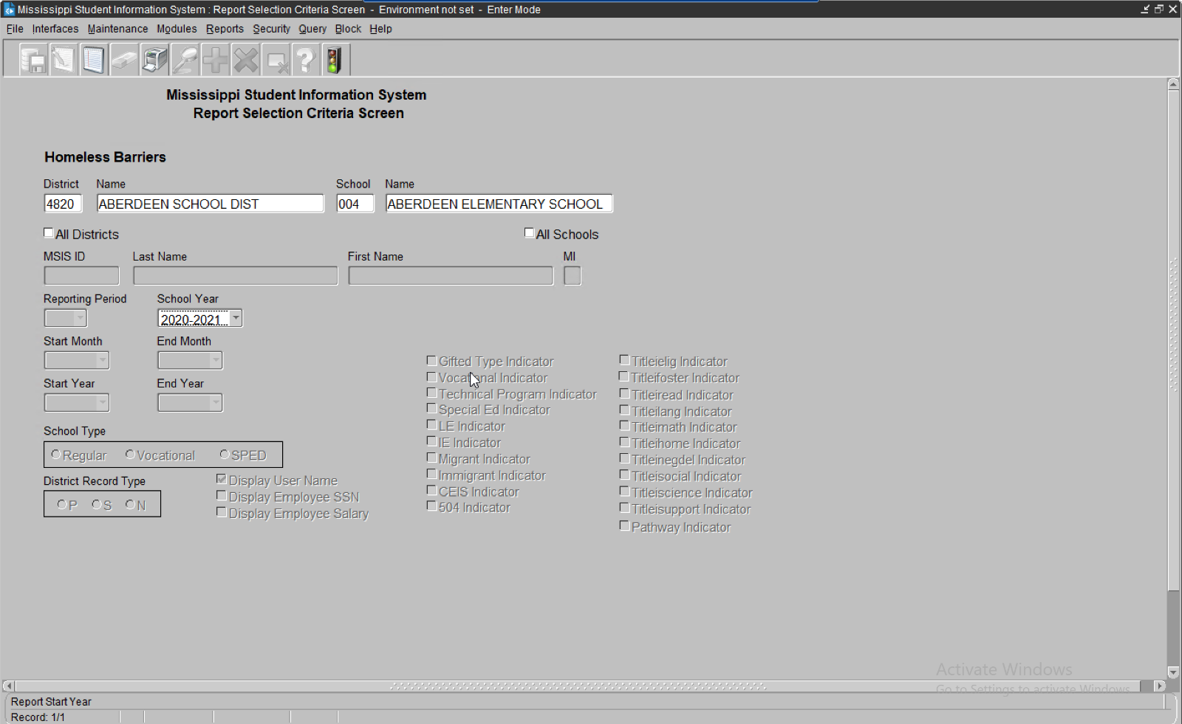

**OR** –select All Schools to receive a report of all Homeless students in a selected school or the district

The report will produce **ONLY** if a selection is made on the MSIS, Homeless Services and Barriers screen with a living condition next to a student’s name. If no selection is made on the MSIS screens, the report will appear blank.

***Note:*** *Report appears in PDF. If the report does not appear – Turn off Pop-Up-Blocker*

# Homeless Report #2

Enter MSIS, Reports, Student Data, Student Indicators

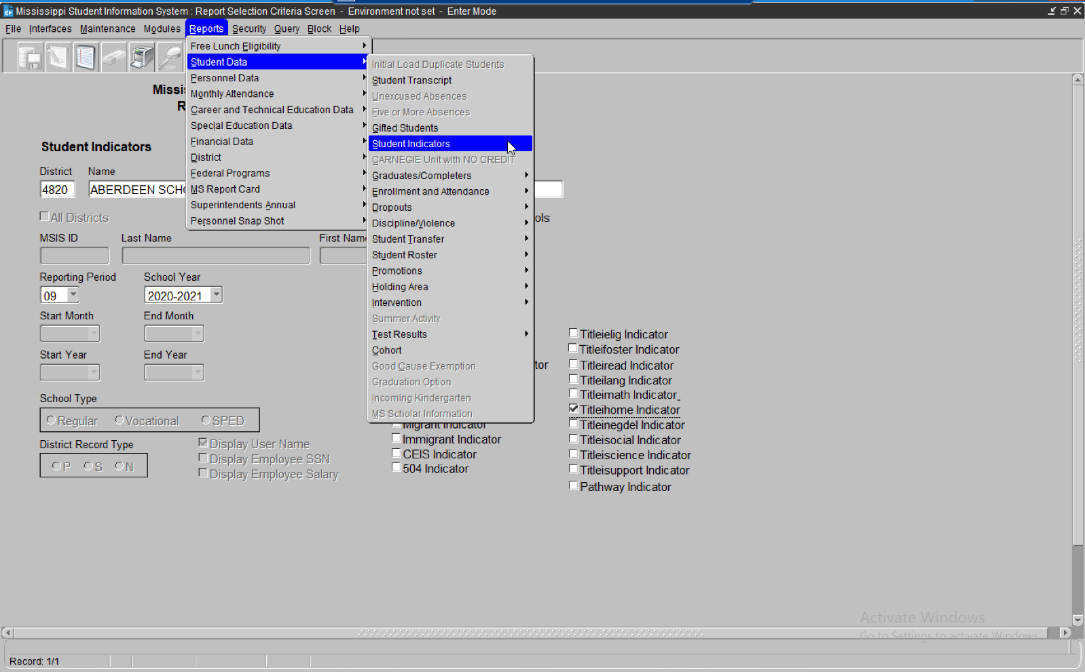

Select a school or check All Schools, check the **Titleihome** indicator

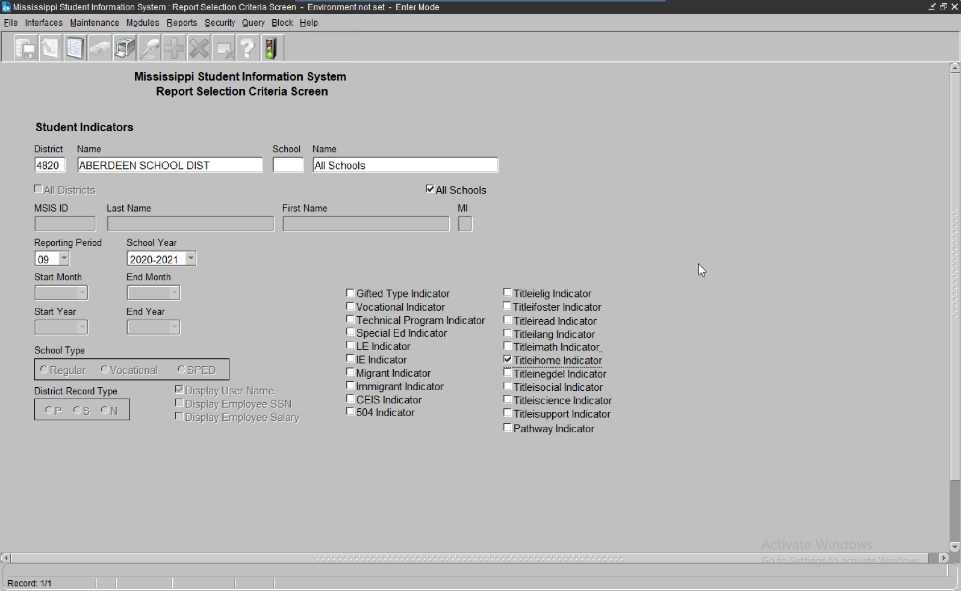

Reporting Period is MSD file month. The month can be changed to a previous reporting month and the school year can be changed to a previous school year. **Run Report**

***Note:*** *Report appears in PDF. If the report does not appear – Turn off Pop-Up-Blocker*

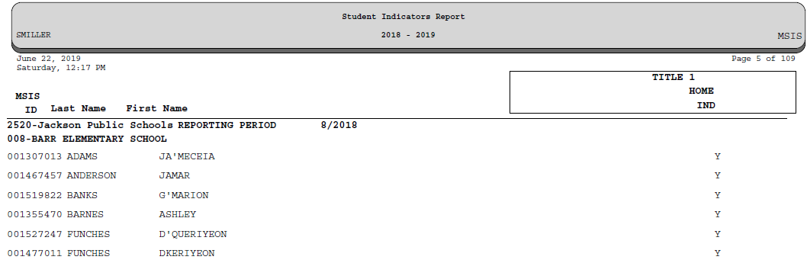

MSIS indicator selected appears here

District’s number, name and school appears here

Student’s names and MSIS ID appears here

***Note*:** Reset the Homeless student indicator to “N” in the SAP after Month 9 data district submission is complete.

# Residency Verification Form (SAMPLE)

**SAMPLE RESIDENCY INFORMATION FORM School Year 20 /20**

This questionnaire is in compliance with the McKinney-Vento Act, U.S.C. 42 § 11431 et seq. Your answers will help determine if the student meets eligibility requirements for services under the McKinney-Vento Act.

Student Name

**  **ale ** **Female

School Phone/Phone #2 Age Grade D.O.B. / / SS#(*last 4 digits*)

Address City Zip Code Is this address Temporary or Permanent? (circle one)

**Permanent Temporary**

Please choose which of the following situations the student currently resides in (you can choose more than one):

* House or apartment with parent or guardian ** **Motel or Hotel
* Car, or campsite, park, temp trailer, streets/bridges, abandoned buildings.
* Shelter or other temporary housing
* With friends or family members (other than or in addition to parent/guardian)

If you are living in shared housing, please check all of the following reasons that apply:

* Loss of housing ** **Economic situation and/or Loss of Employment
* Temporarily waiting for house or apartment ** **Provide care for a family member
* Living with boyfriend/girlfriend ** **Parent/Guardian is deployed
* Other (Please explain)

Are you a student under the age of 18 and living apart from your parents or guardians? Yes No

**Residency and Educational Rights**

Students without fixed, regular, and adequate living situations have the following rights:

* 1. Immediate enrollment in the school they last attended or the local school where they are currently staying even if they do not have all of the documents normally required at the time of enrollment without fear of being separated or treated differently due to their housing situations;
  2. Transportation to the school of origin for the regular school day;
  3. Access to free meals, Title I and other educational programs, and transportation to extra-curricular activities to the same extent that it is offered to other students.

Any questions about these rights can be directed to the district McKinney-Vento Liaison or the State Coordinator at MS Department of Education at *601-359-3499*.

By signing below, I acknowledge that I have received and understand the above rights.

*Printed Name and Signature of Parent/Guardian/Unaccompanied Youth Date*

*District/School Use Only – District Homeless Liaison determination of the above circumstances:*

Homeless Yes No Unaccompanied Youth Yes No

Living Condition (*circle one*) **Doubled-Up Hotel/Motel Shelter Unsheltered** Date: /_ /_

*Printed Name and Signature of McKinney-Vento Liaison Date*

# Limited English Proficient/English Language Learner

Enter MSIS, Modules, Federal Programs, ELL

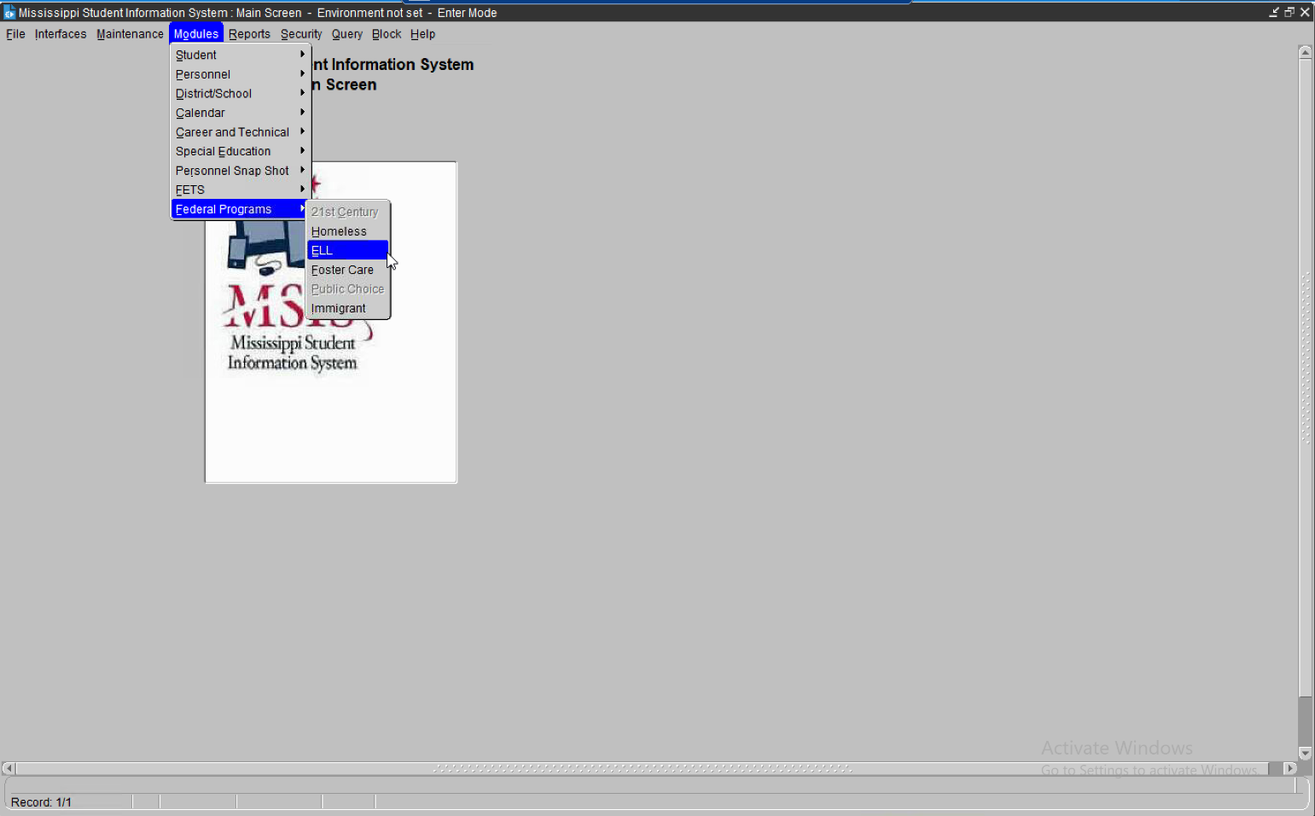

# Title III, Part A

**A Limited English Proficient/English Learner** is one:

* + - who is ages 3 through 21;
    - who is enrolled or preparing to enroll in an elementary school or secondary school;
    - who was not born in the United States or whose native language is a language other than English;
    - who is a Native American or Alaska Native, or a native resident of the outlying areas; ~~and~~
    - who comes from an environment where a language other than English has had a significant impact on the individual’s level of English language proficiency; or
    - who is migratory, whose native language is a language other than English, and
    - who comes from an environment where a language other than English is dominant; and whose difficulties in speaking, reading, writing, or understanding the English language may be sufficient to deny the individual - the ability to meet the State’s proficient level of achievement on State assessments described in *Section 1111(b)(3)*; with the ability to successfully achieve in classrooms where the language of instruction is English; or the opportunity to participate fully in society.

NOTE: Reset the ELL/LEP/EL/LE student indicator to “N” in the SAP after Month 9 data district submission is complete.

# Contact Information Tab

Please complete all information on this screen. Click SAVE - 

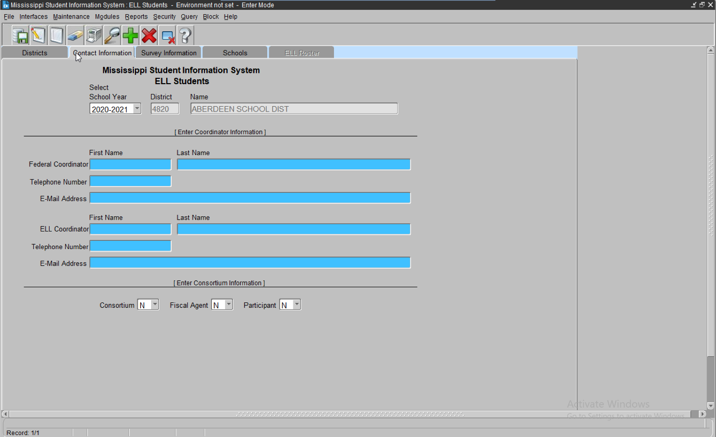

# Survey Information Screen

Please complete all sections of this screen as it applies to the district. Click SAVE - 

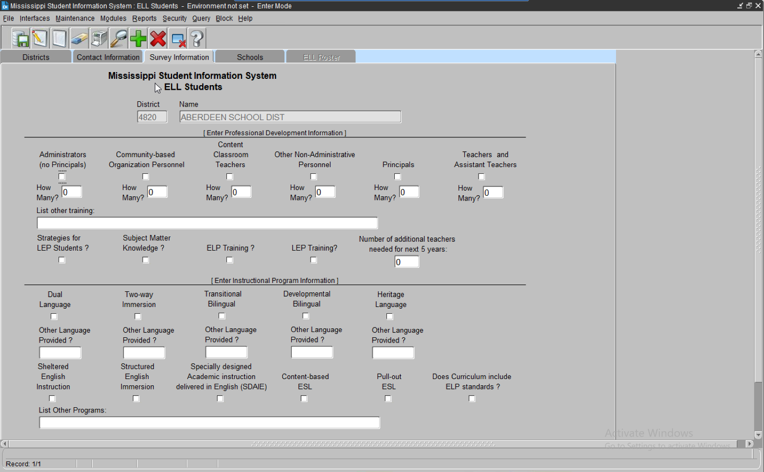

**School Tab -** Please select a school in the district

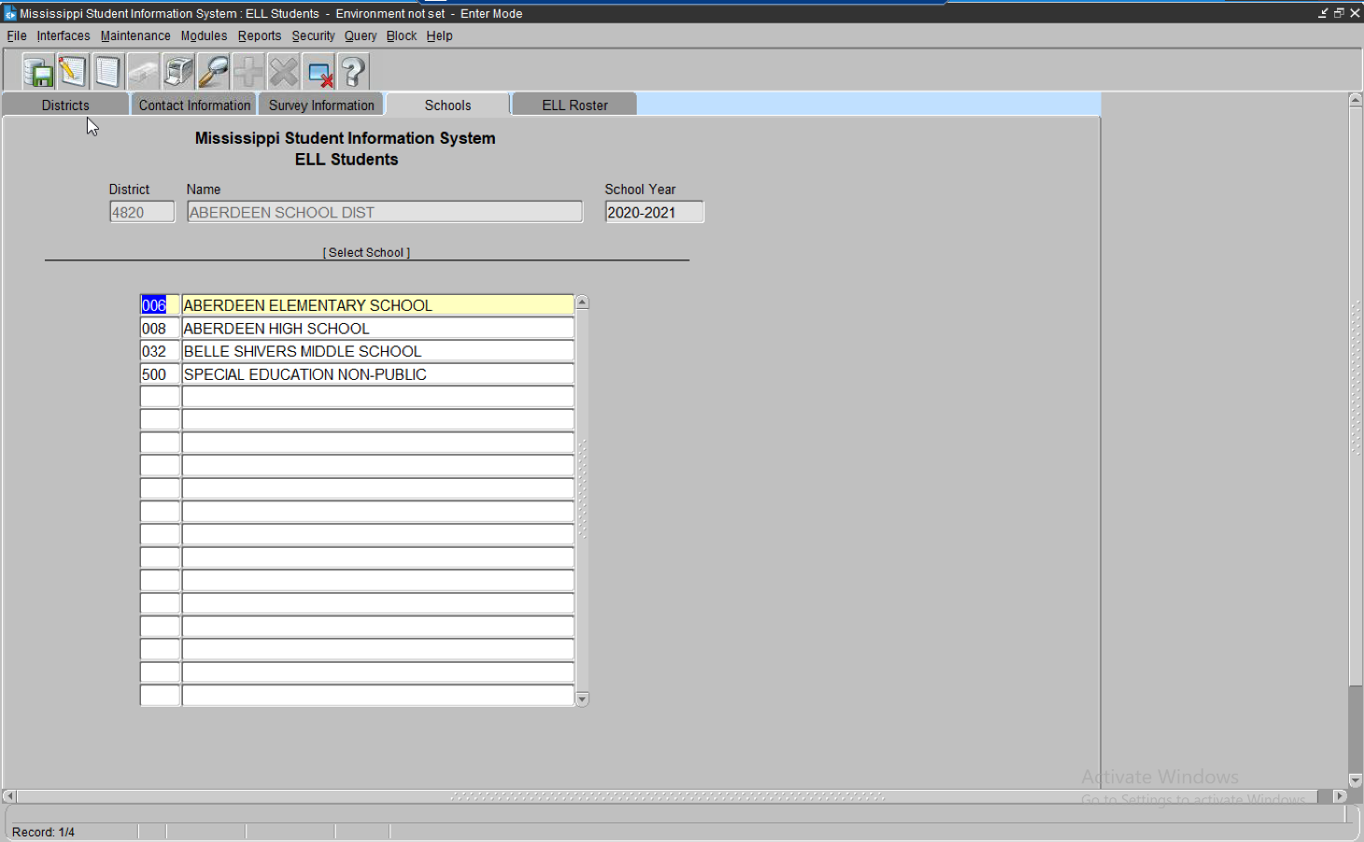

# ELL Roster Tab

The screen will display students that have been identified in the SAP with a “Y” as LE and were submitted in the monthly student data for the district. The students will appear on the screen **AFTER** the district data was approved for the reporting month.

Each area next to the student’s name must be completed by the Federal Program Director and properly updated as needed. Please view this screen for any new students and make the selections. **MONTHLY**. Click **SAVE** - 

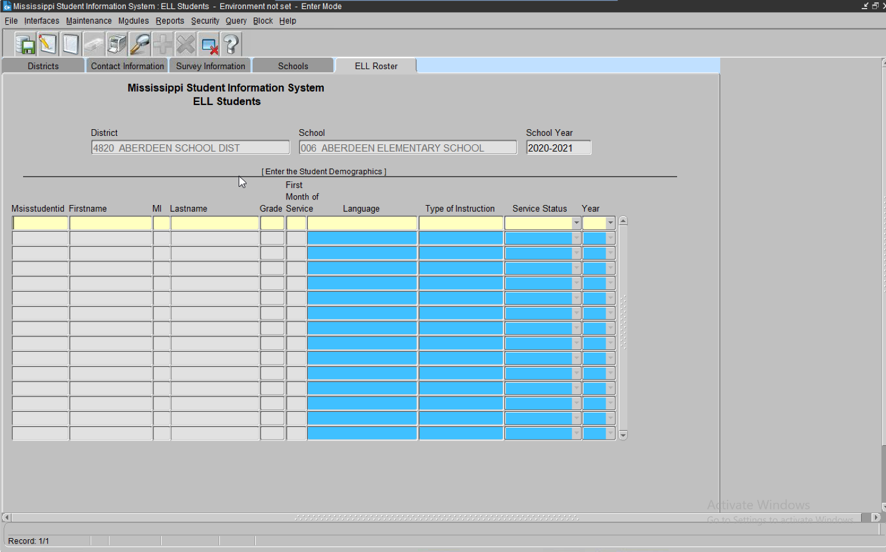

**Note:** You **cannot remove** a student from this screen. If student has been misidentified immediately contact the school in which the student is enrolled and change the LE indicator to “N”. Please leave all areas next to the student’s name blank on this screen. This will indicate a misidentification and the student will not be reported as LEP/ELL.

# First Month of Service

The reporting month of the school year in which the data was submitted to MSIS.

# Language

The native language at birth or most commonly spoken in the home. **If a language spoken is not in the drop-down list, please select the standard language of the home country.** MDE uses the ISO 639.2 List from the Library of Congress. The ISO 639-2 language codes can be found on the [Codes for the Representation of Name of Languages](http://www.loc.gov/standards/iso639-2/php/code_list.php) web site.

What if a student has a language (native) that is not on the list?

In the event that a student has a native language that is not included in the list, try to determine the language family for that language. Additional information on the language families is contained on the [Enthnologue website](https://www.ethnologue.com/).

An example of this would be for students who speak the Maay language. This language is not included in the language list. According to the Ethnolgue Web site Maay is a Cushitic language. The ISO 639-2 has a value for Cushitic (Other). In this case you would report your Maay speaking students under “Cushitic (Other).” In the explanation field include a comment that the students in this category speak the Maay language.

# Type of Instruction:

A language instruction educational program (LIEP) is a course in which an English learner is placed in order to develop and attain English proficiency while meeting challenging State academic standards. An LIEP may include instruction in English and a child’s native language, and English proficient children may participate in the course if the course is designed to enable all participating children to become proficient in English and a second language (ESEA section 3201(7)).

List of Instructional languages to choose from:

* Dual Language
* Two-way
* Transitional bilingual program
* Developmental bilingual – (***MS doesn’t have)***
* Heritage language – (***MS is an English only state)***
* Sheltered English instruction
* Structured English immersion
* Specially designed academic instruction delivered in English (SDAI)
* Content-based ESL
* Pull-out ESL

# Service Status

**Monitored** – An ELL student who was receiving services but has officially exited the program based upon the exit criteria in the ELL Guidelines.

**Served -** A student that has indicated that English is a Second Language on the Home Language Survey.

**Years** – Years served in the district as LEP identified only.

If student has been identified as Monitored - **Select 1, 2, 3, or 4 years, *ONLY*.**

# 

# Limited English Proficient/English Language Learner - Report #1

Enter MSIS, Reports, Federal Program, ELL, Student Roster/Pre-IDS

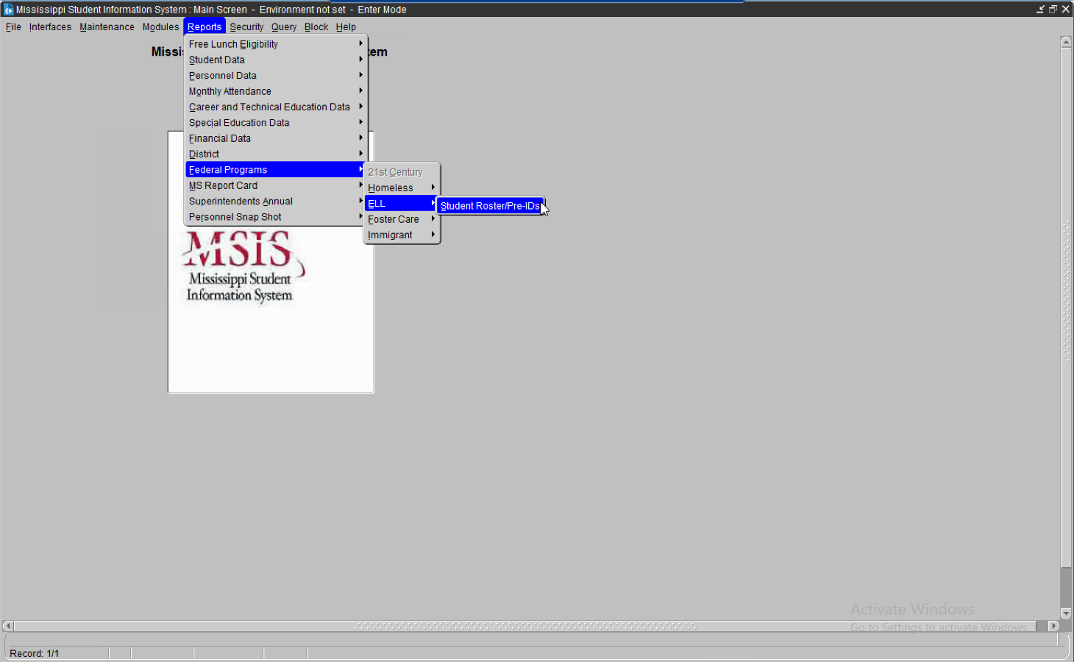

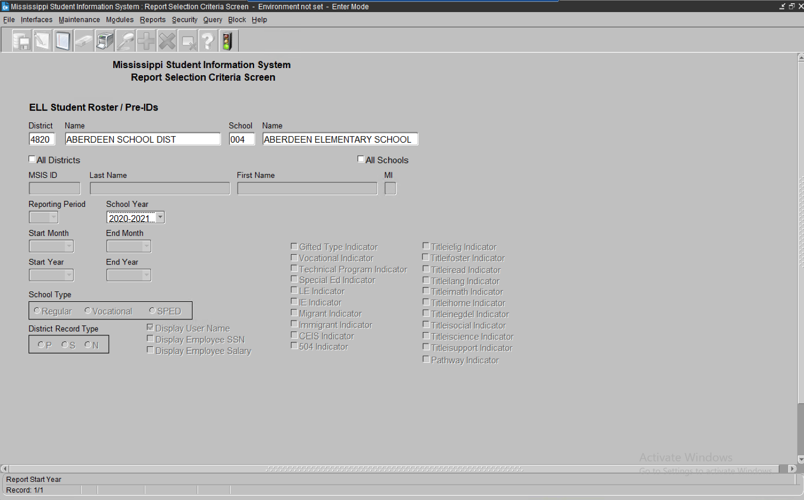

Run Report

***Note:*** *Report appears in PDF. If the report does not appear – Turn off Pop-Up-Blocker*

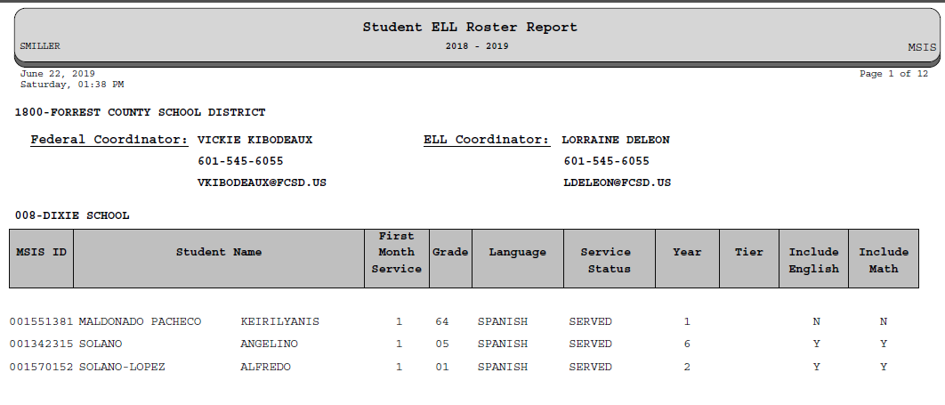

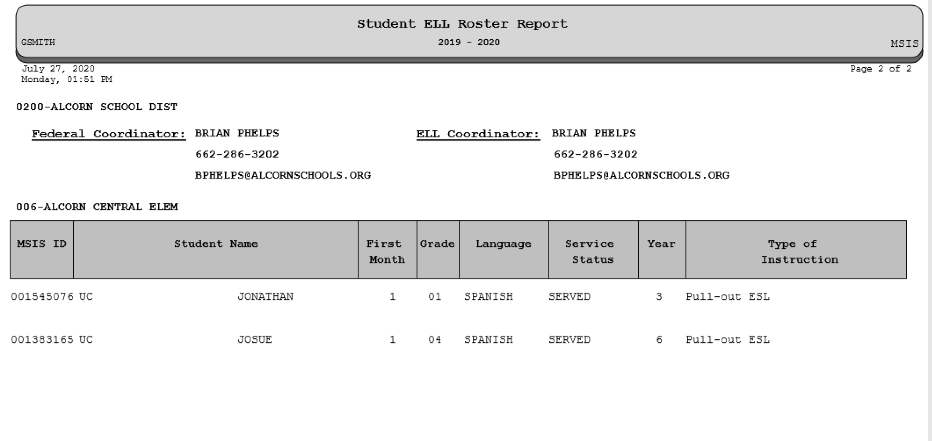

ELL Coordinator contact information

MSIS ID and student’s name

Dsitrict number and name

School number and name

Federal Coordinator contact information

The students will appear on the report that have the indicator set as “Y” in the SAP. This is submitted in the monthly student data for the district. The report will produce **ONLY** if a selection is made on the MSIS, ELL Roster screen next to a student’s name. If no selection is made on the MSIS, ELL Roster screen, the report will appear blank.

Once the schools have submitted the MSD file and received a Success from MDE and the district approves the data, all students must be verified in MSIS **BEFORE** the next reporting period begins.

##### *** Note on ELL Students ***

ELL (LEP) Students: There was a lot of confusion concerning LEP student indicators not showing as marked correctly in MSIS. It was determined that for Districts that are SAMS users, you must mark the **LE** (Limited English) indicator and the **Title I** indicator for those students in your package. This will allow your students to be correctly identified as LEP students when your file is submitted to MSIS.

For those Districts that are not SAMS users, please contact your Vendor on how to correctly identify these students in your student package.

# Limited English Proficient/English Language Learner - Report #2

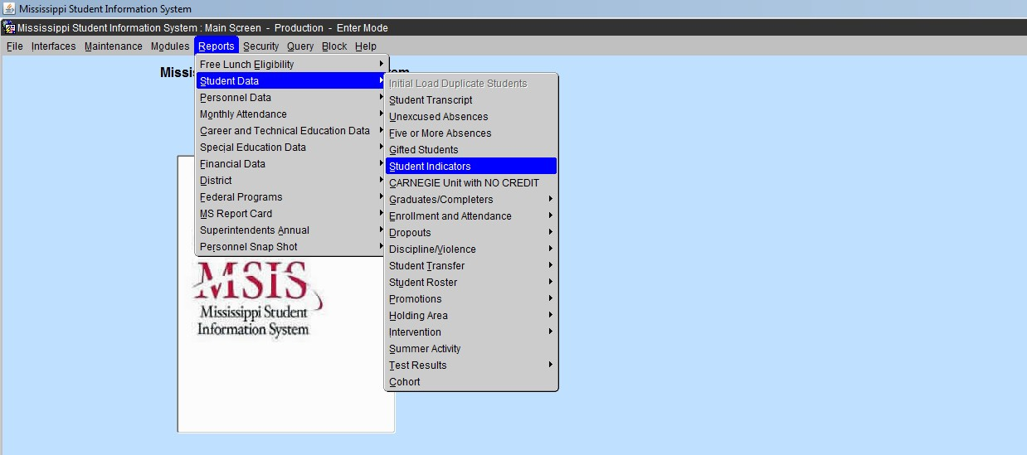

MSIS, Reports, Student Data, Student Indicators, select the **LE Indicator**, Run Report

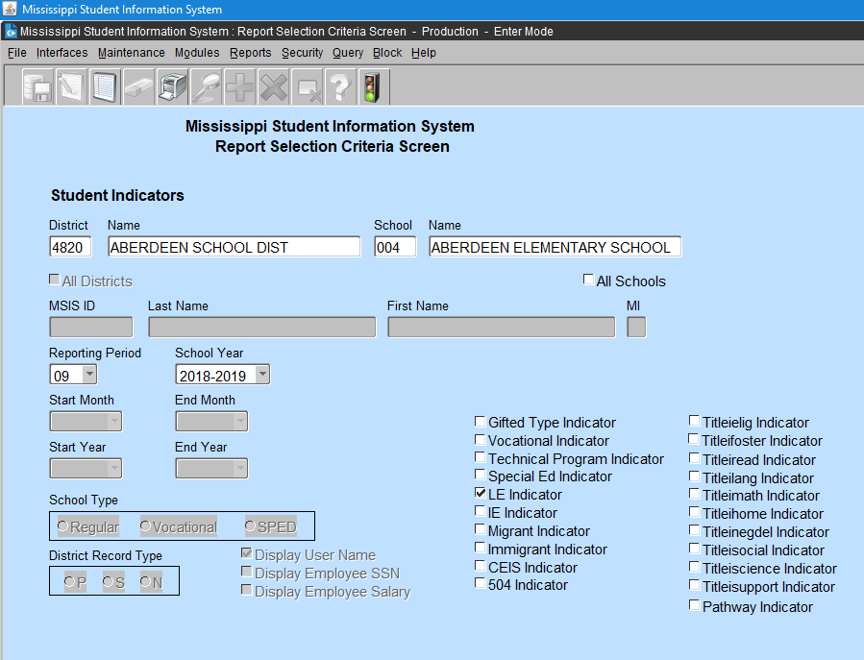

Click to run report

This is a streamlined report listing students that have a LE indicator of **“Y”** in the SAP.

You are able to select the monthly reporting month during the current school year to view your students.

You may make as many selections desired to view students with indicators of **“Y”** in the SAP that was submitted to MSIS in the monthly reporting.

***Note:*** A student can have more than one indicator selected to “Y”, if they qualify for the services. ***e.g.*** A student can be an Immigrant, Migrant and LEP.

The report appears in PDF

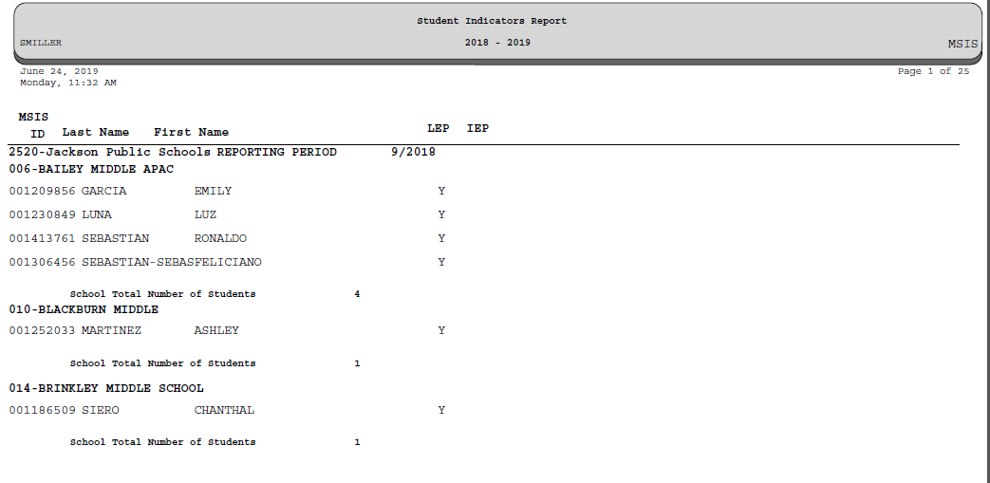

The student indicator is **“Y”** in the SAP and his/her information is displayed on this report for the reporting period at the top of the student list.

Properly identify the students listed. If any students are listed in error, forward a copy to the home school and request a change to the student indicator from “Y” to “N”. This report can be used for corrections before the next reporting period.

*Note*: Reset the ELL/LEP/EL/LE student indicator to “N” in the SAP after Month 9 data district submission is complete.

**HOME LANGUAGE SURVEY**

The Home Language Survey must be completed for all new entering students **at the time of registration** **and remain in the student’s cumulative folder until graduation.**

If any response on the Home Language Survey indicates the use of a language other than English by the student or an individual in the home, then further assessment must be conducted to determine the student’s English Language proficiency.

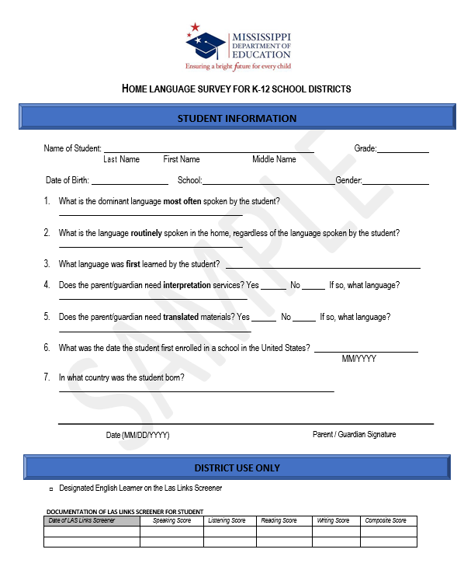

# Immigrant

The Immigrant student indicator is selected in the SAP as **“Y”**. The indicator must be selected in the SAP **BEFORE** the submission of the monthly student data file to MDE.

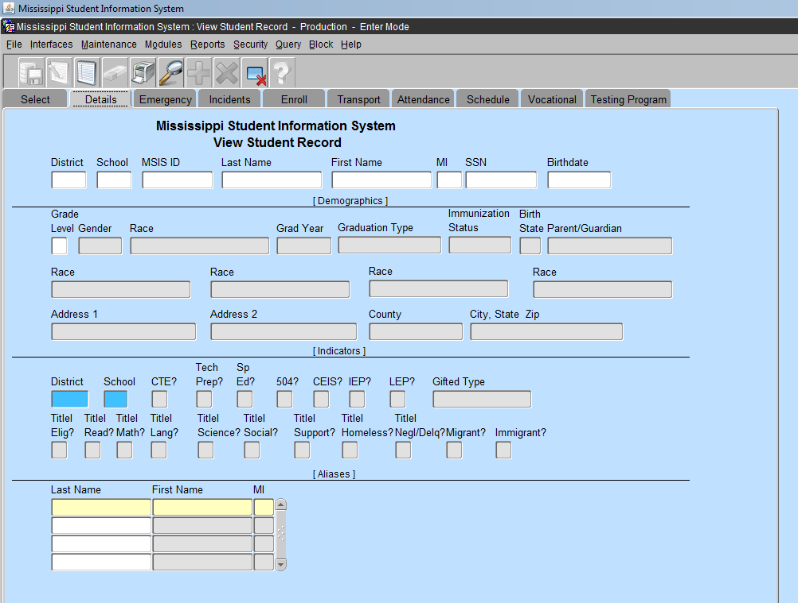

Student Indicator “Y”

# Title III, Part A

**Section 3301(6) defines Immigrant Children and Youth as individuals who-**

* 1. are ages 3 through 21;
  2. were not born in any state or U.S. territory;

(c) have not been attending one or more schools in any one or more states in America or US Territories for more than three full academic years.

# Are children (students) born to U.S. citizens abroad (e.g., children born on a military base overseas) considered immigrants?

**YES…**if they meet the above criteria’s in the definition of immigrant.

***Definition: Children that are born out of the United States or U.S. territory to parents or couples that are US citizens, born or naturalized, are to be identified as Immigrant.***

Once a student has completed **three full** (consecutive) academic school years (MS public, private and homeschool, or any type of out of state school), she/he is no longer identified as Immigrant.

*e.g. Academic school year is MS school attendance calendar =* ***Aug thru May/June. Other states school attendance calendar may vary.***

Only include summer school if the student is a Migrant and the classes are part of the Migrant Education Program.

**NEW! Immigrant Student Screen**

**Modules > Federal Programs > Immigrant**

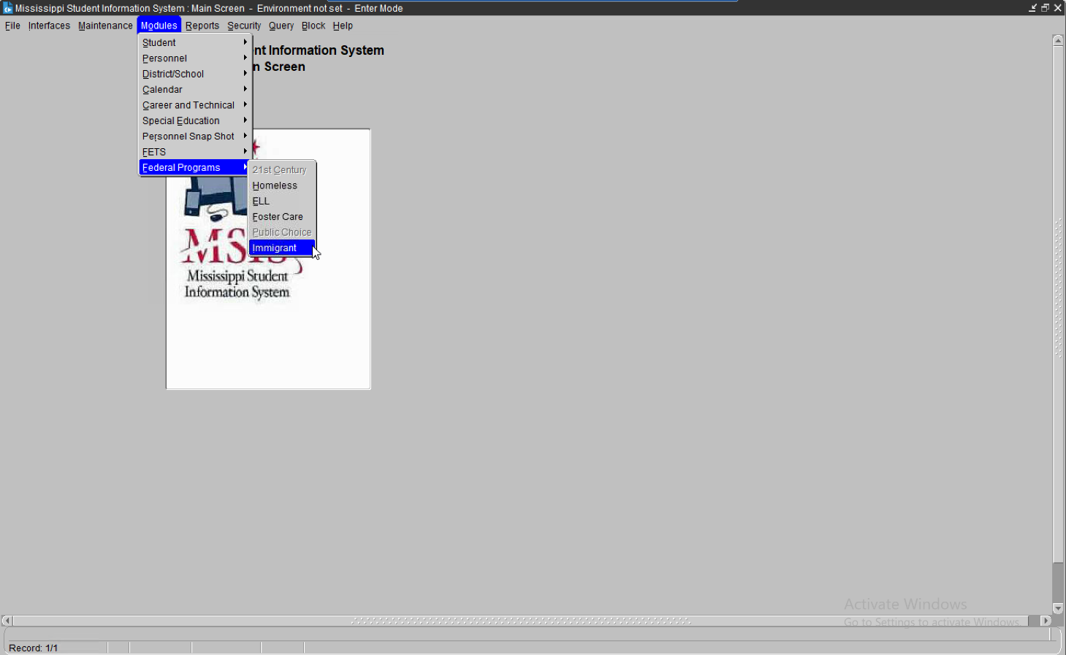

**Immigrant languages are to be entered in MSIS. If there are Immigrant students on the Immigrant screen, the language must be selected.**

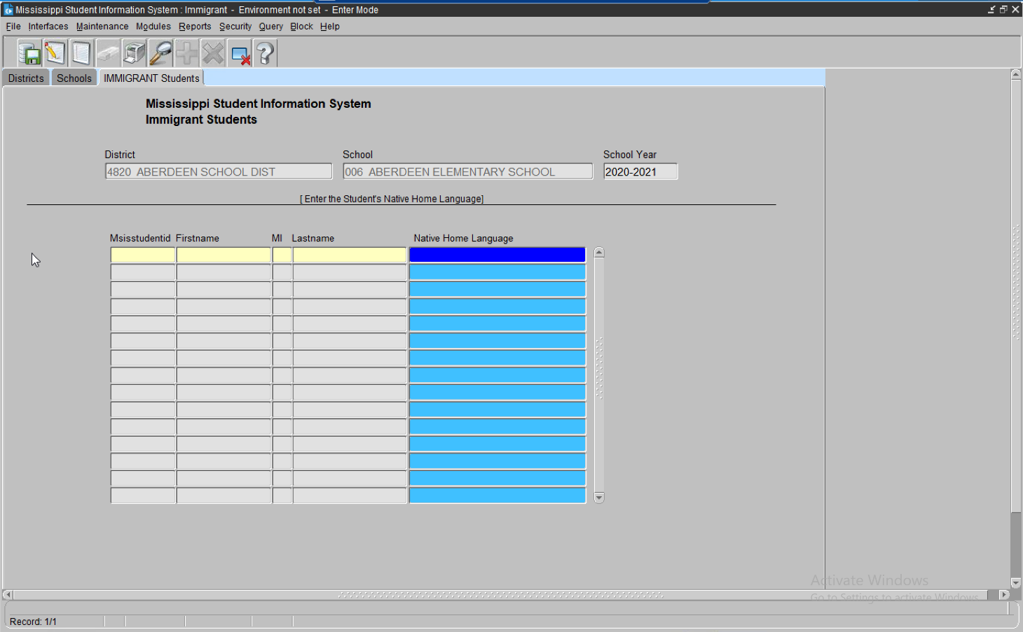

# Immigrant Report – Native Language

# Reports, Federal Programs, Immigrant, Native Language

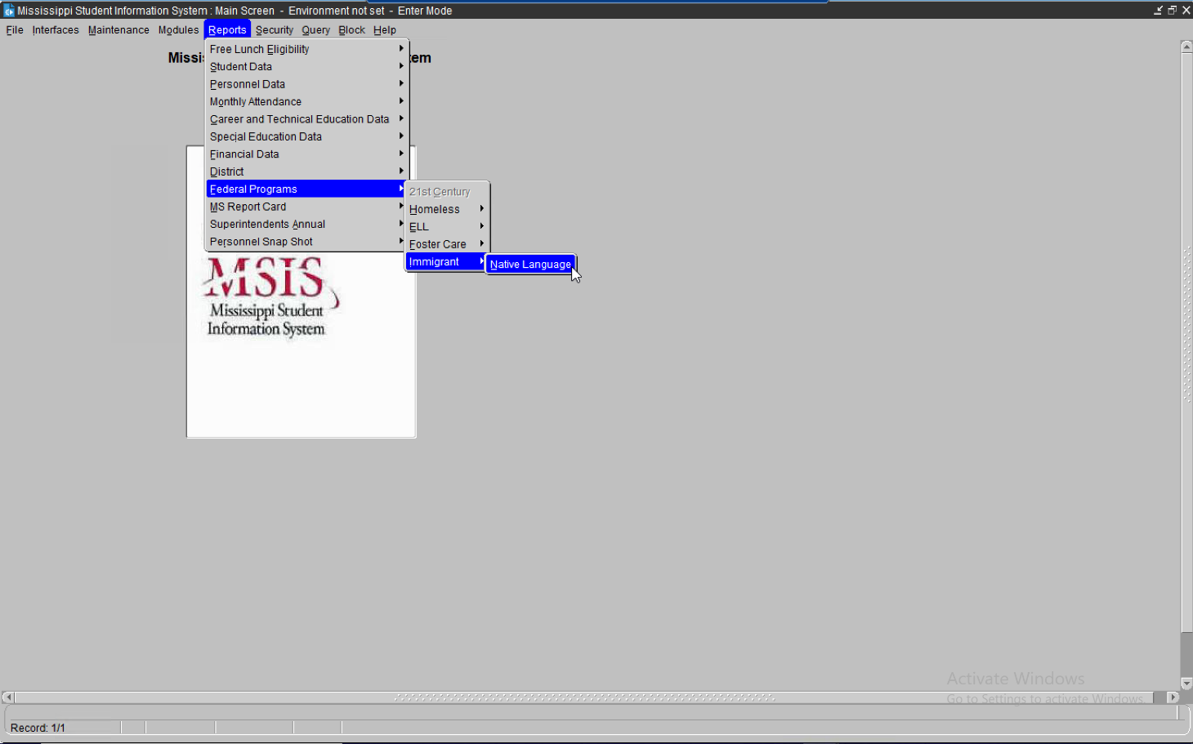

This report list Immigrants and their native languages.

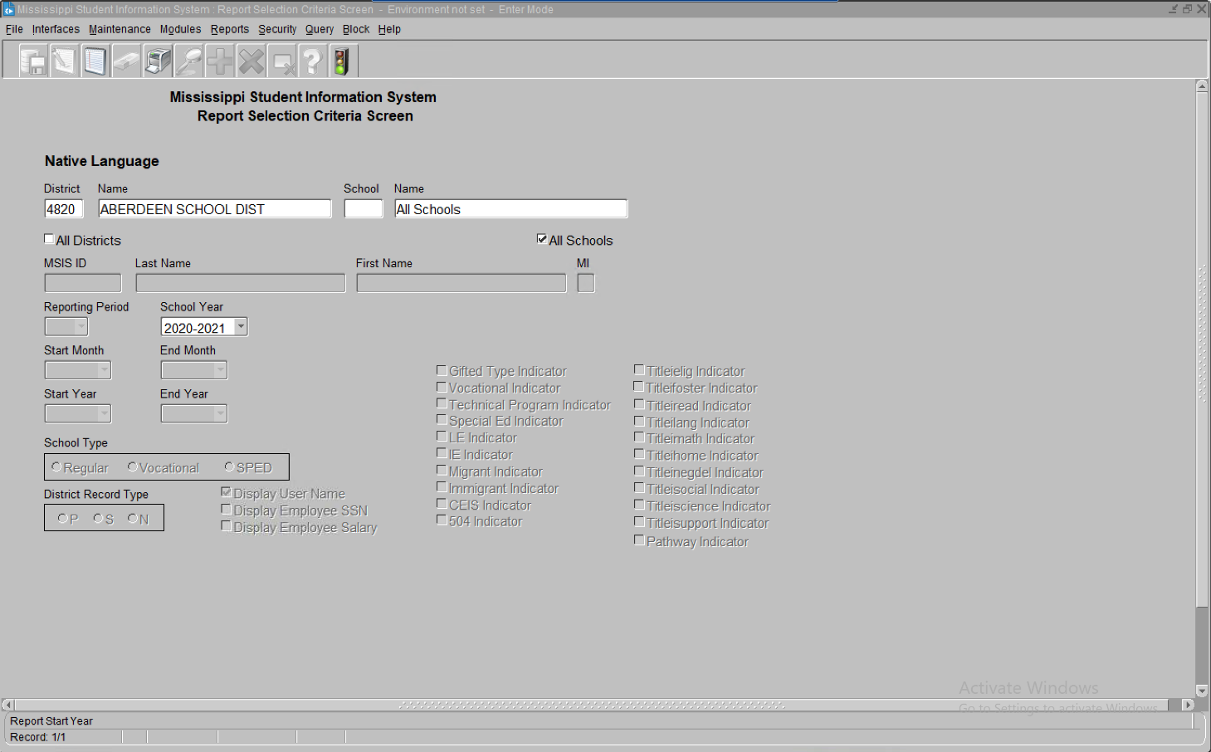

MSIS, Reports, Student Data, Student Indicators, select Immigrant Indicator **Run Report**

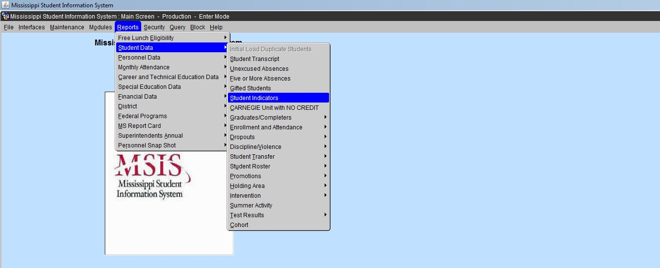

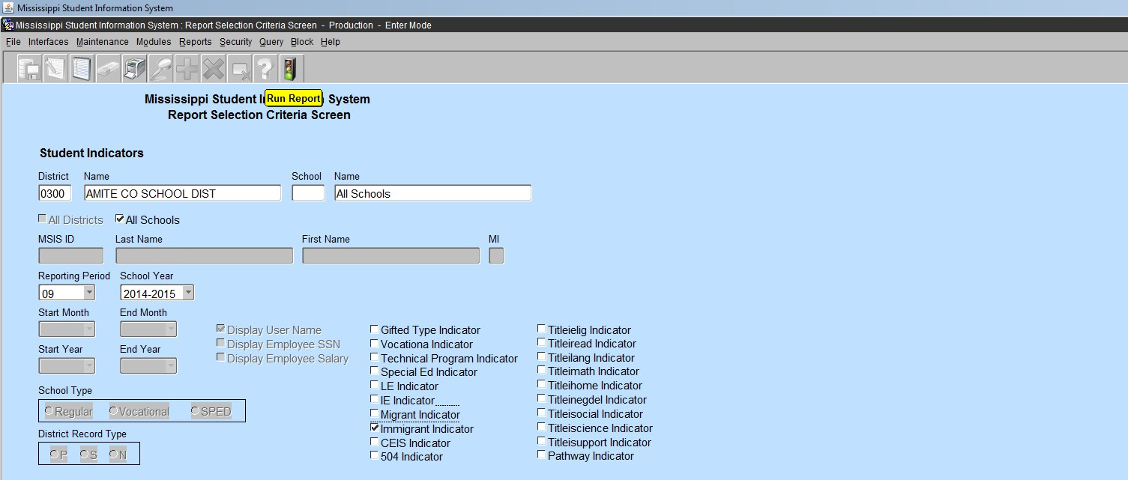

The report appears in PDF. The students with an indicator of “Y” in the SAP will appear on this report.

*Note*: Reset the Immigrant student indicator to “N” in the SAP after Month 9 data district submission is complete.

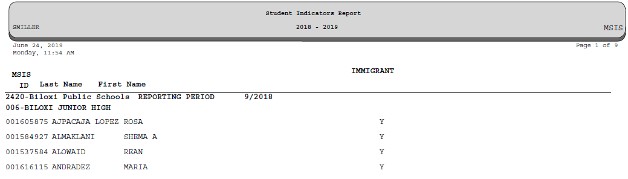

# Migrant

A Migrant indicator is marked in the SAP as “Y”. The Mississippi Migrant Education Service Center (MMESC) will notify the district of children who qualify as migrant (see below).

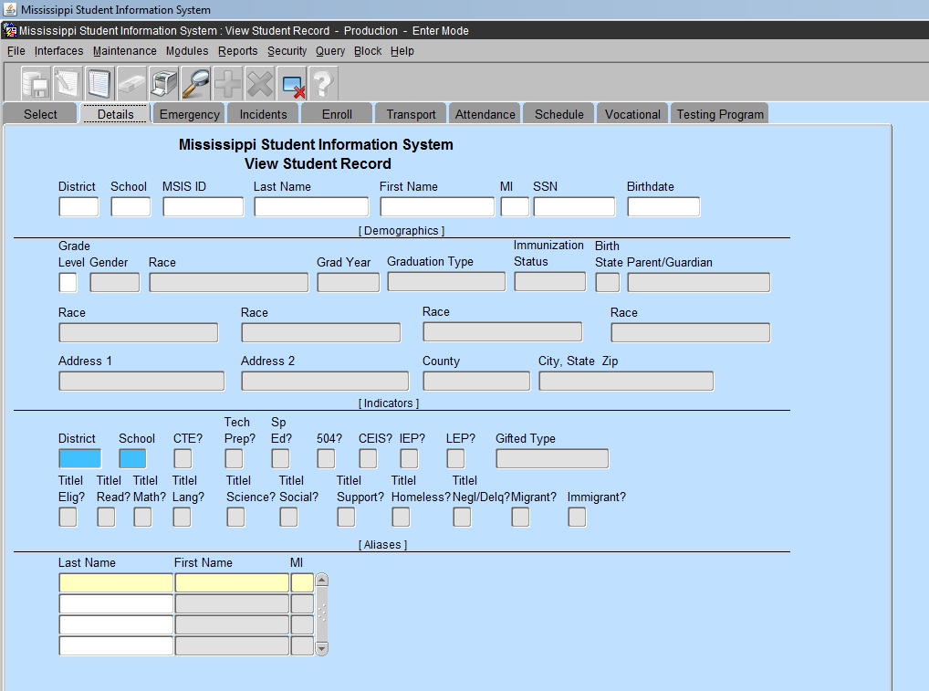

Student Indicator “Y”

**Title I, Part C**

**A Migrant child** is 3-21 years of age and has not graduated from high school or obtained a GED. The child or the child’s parent(s), guardian(s), or spouse is a migratory agricultural worker or fisher and has moved within the past thirty-six months from one school district to another due to economic necessity. The move has enabled the child, or the child’s parent, guardian, or spouse, to either engage in temporary or seasonal agricultural or fishery employment, or actively seek such work while having a history of moves with qualifying employment.

If a student is enrolling in or has enrolled in the district and the district representative identifies the student as a potential migratory child, contact the Coordinator of Identification & Recruitment at the Mississippi Migrant Education Service Center (MMESC) immediately (ph. 662.325.1815).

Do not mark the indicator in the SAP as “Y” until receiving confirmation from MMESC. Only MMESC can make the determination of whether a student is a qualifying migratory child. MMESC will convey a list of qualifying migratory children to the district (see below).

# Migrant Report

MSIS, Reports, Student Data, Student Indicators, select Migrant Indicator - Run Report

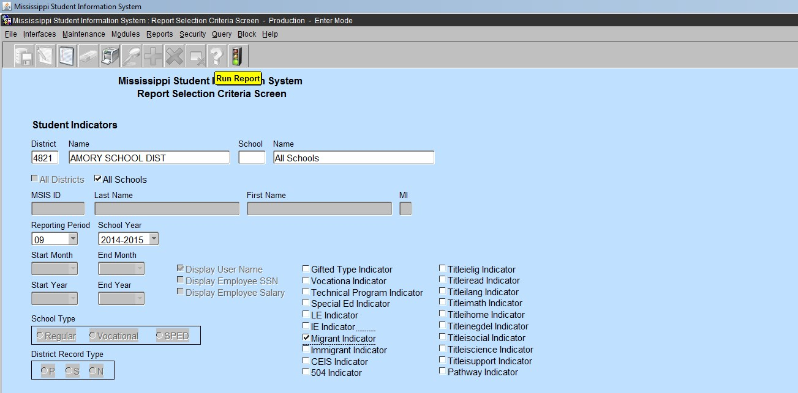

Report appears in PDF.

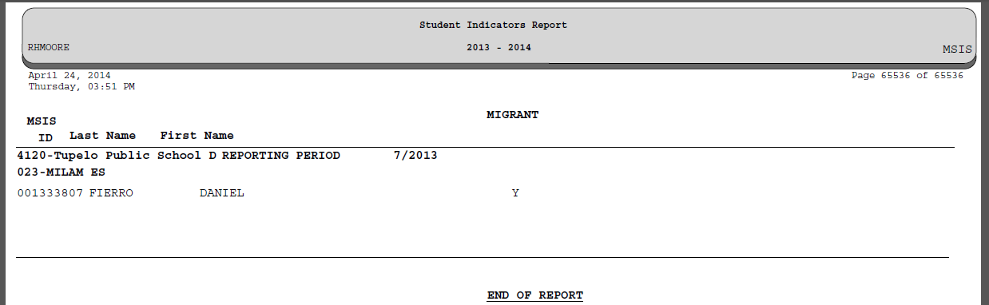

MSIS requires the indicator to be marked **“ Y ” after** the student has been determined to be a migrant student by MMESC.

Migrant student data is captured, stored and reported in the MIS2000 database on behalf of the MDE by MMESC, at Mississippi State University. This system collects and stores Migratory data for the state of Mississippi and over 25 other states. Data collected in MIS2000 is shared with MDE and the U.S. Department of Education, Office of Migrant Education. MIS2000 is owned and operated by Management Services for Education Data (MS/EdD), in Little Rock, AR.

**Note: School Districts do not make the determination of whether a student is marked as a migrant student in MSIS. This determination can only be made by MMESC.** A list of qualifying migrant students will be sent to districts from MMESC. It is very important to accurately report the information in MSIS as indicated in this migrant student list.Accurate data entry enables MDE’s accurate submission of a required biannual report on migratory students educated in Mississippi to the U.S. Department of Education, Office of Migrant Education.

# Neglected or Delinquent

Enter MSIS, Modules, Student, View Student Data

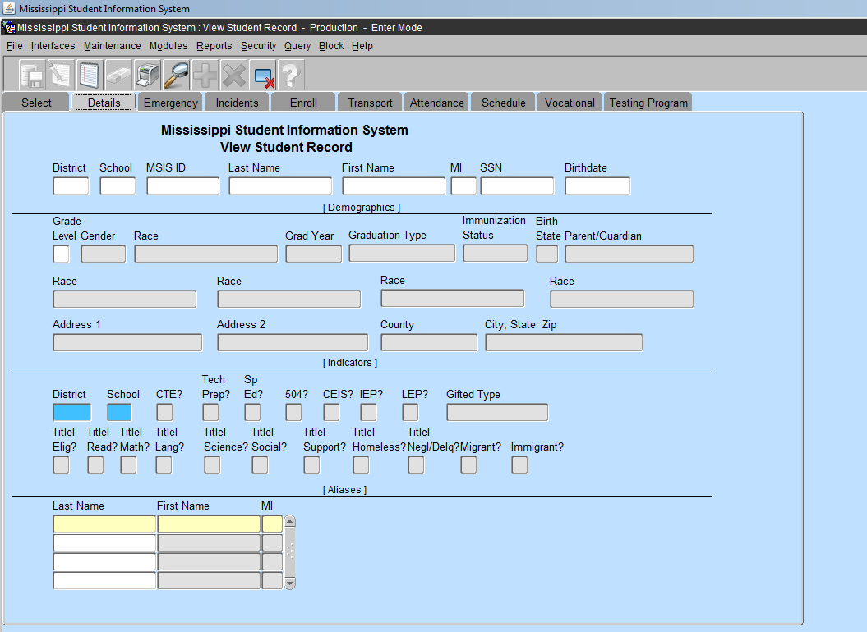

# Title I, Part D – Subpart I (State Agencies) and Subpart II (District)

Title I, Part D consists of 2 discretionary subparts.  Subpart 1 is allocated to state agencies (Mississippi Department of Corrections and Mississippi Department of Human Services/Division of Youth Services). Subpart 2 is allocated to school districts with institutions, in their local attendance areas, for children meet the federal definition of delinquent (juvenile detention centers).

# A delinquent child as defined in section 1432; 4(B) of ESEA is a child or youth ages 15-21 who have been placed in a facility because they have been adjudicated to be delinquent or in need of supervision by court orders.

The student indicator is selected in the student package with a **“Y”** at the homeschool.

**Note:** Once a student has entered a Juvenile Detention Center (JDC) the indicator must be selected to **“Y”** and an incident identifying the student action is created and sent to MSIS within 72 hours. Then it is followed by the disposition of JDC with the duration days of stay at the facility. This information is sent from the homeschool as a Daily Student Data (DSD) file. The indicator must remain checked until the student returns to the homeschool. If a student has served only a weekend in the JDC, please check the indicator immediately and leave selected until the monthly student data file has been accepted at MDE, then change the student indicator to **“N”** in the SAP.

A student must **remain enrolled at the homeschool and marked present everyday** while in the JDC until they return to the homeschool. The student **must be released in MSIS** to the JDC or state approved coordinating facility that request a release of the MSIS ID.

Students **that have been sentenced to an adult correction facility or prison** must be removed from the homeschool enrollment with the appropriate dropout code with supporting court documentation.

# Neglected or Delinquent Report #1

Enter MSIS, Reports, Student Data, Student Indicator

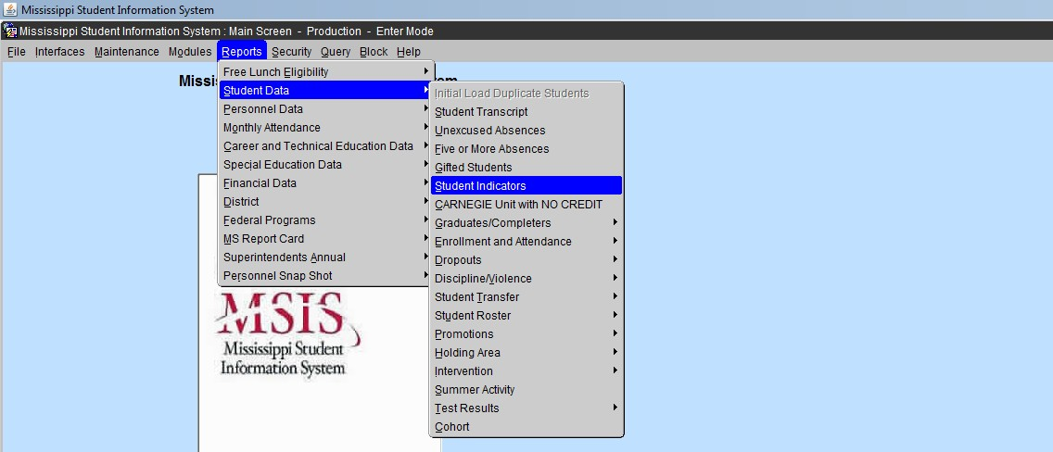

The screen appears to select a reporting month.

The reporting month is a school attendance month, not a calendar month. Select the **Titleinegdel** Indicator

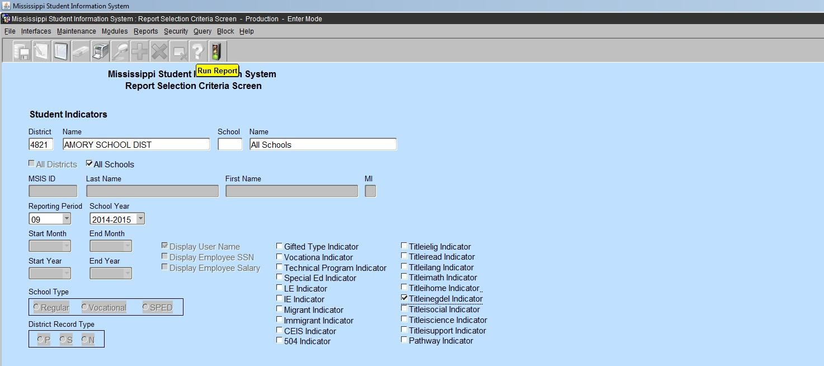

Click the green light – **Run Report**

The report appears in PDF.

The report will list the students names whose indicator was selected as **“Y”** in the student package for the reporting month selected on the screen.

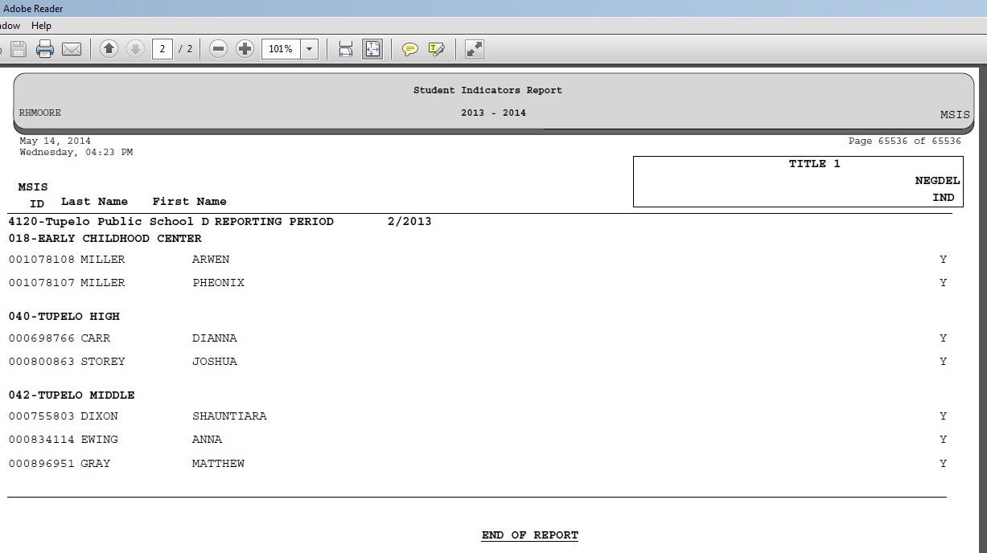

The student will not be listed for a particular reporting month if the indicator is “N” in the SAP during that month.

*e.g.* Month 2 – student indicator is “Y” = student will appear on the report for Month 2 in MSIS

Month 3 – student indicator has been changed to “N” = student will not appear on the report for Month 3 in MSIS.

This occurs **after** the district has approved the MSD file for the month.

# Neglected or Delinquent Report #2

Enter MSIS, Reports, Student Data, Discipline/Violence, Disposition Summary

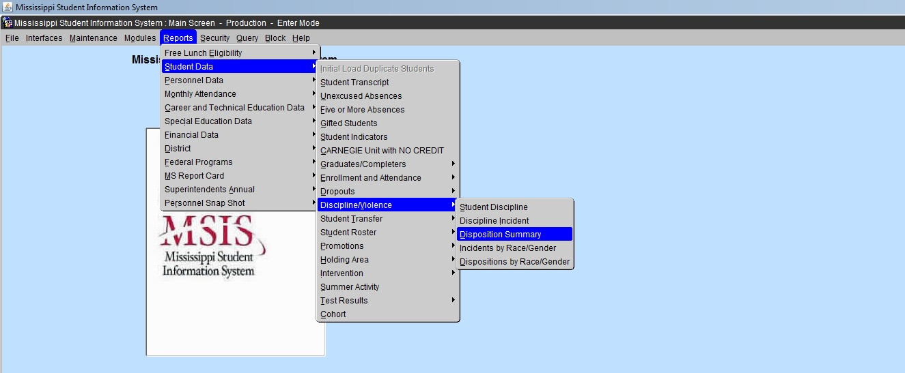

This report will provide a list of students in which all dispositions were sent in a DSD file from the homeschool.

**Incident:** is the action/crime conducted by the student, on and/or off campus during the school year

**Disposition:** the punishment decided upon by the principal/ superintendent/school board to be completed by the student before returning to the classroom.

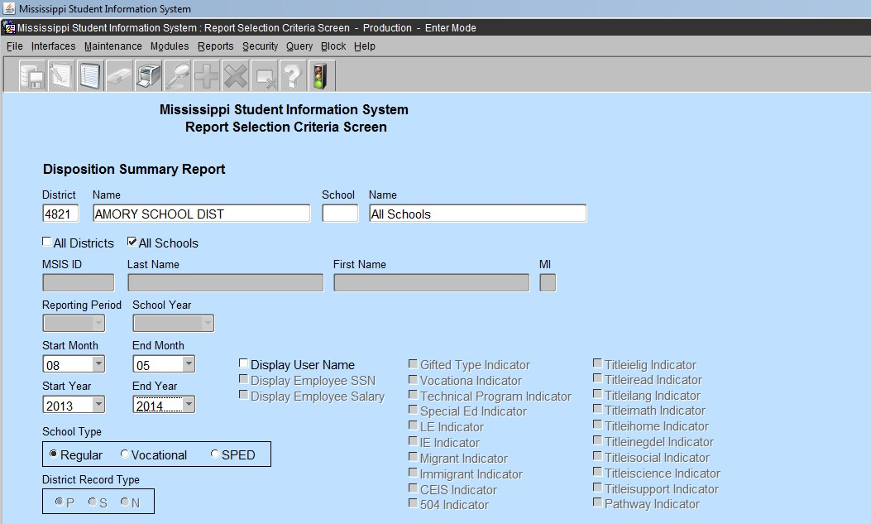

*Click:* **Run Report**

Start and End Month is a calendar month **not the** school reporting month.

* 1. **Start Month** 8 =August **End Month** 5 = May

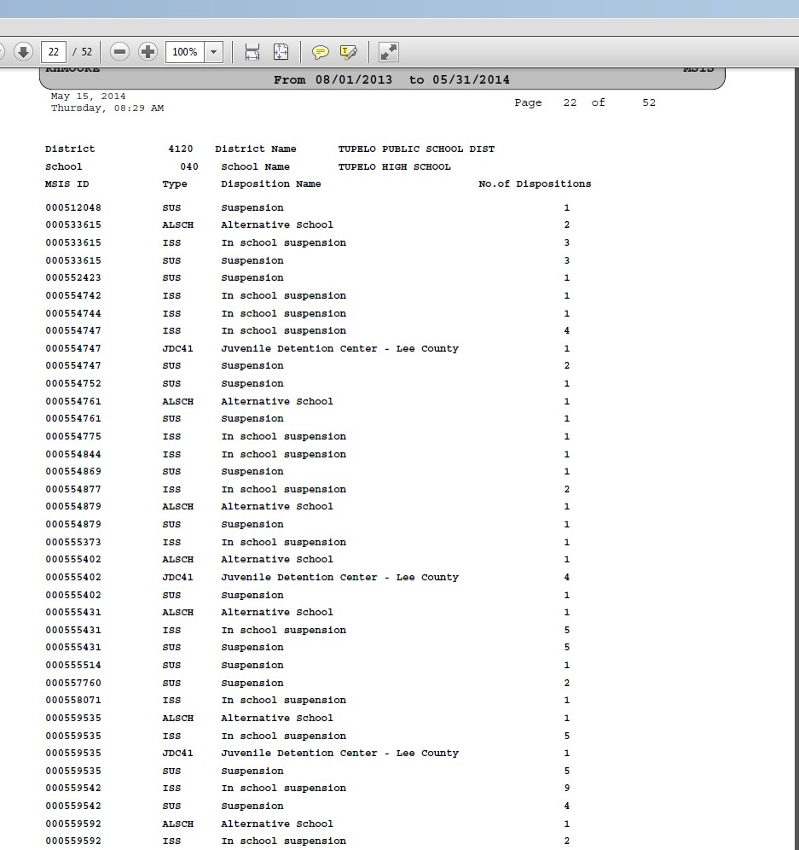

Calendar months selected on the Disposition Summary Screen

The number of dispositions submitted to MDE for that MSIS ID.

The report appears in PDF.

# This report list all students that were submitted with a disposition to MDE in daily student data (DSD) file.

Please print a copy of this report on June 1 and file with the district reports. Dispose of report after Month 1 has been submitted and approved for the upcoming new school year.

# *Note*: Reset the Neglected and Delinquent student indicator to “N” in the SAP after Month 9 data district submission is complete.

# Federal Programs Report

Multiple student indicators can be selected to produce a report of students with more than one program indicator.

MSIS, Reports, Student Data, Student Indicator, select as many as needed

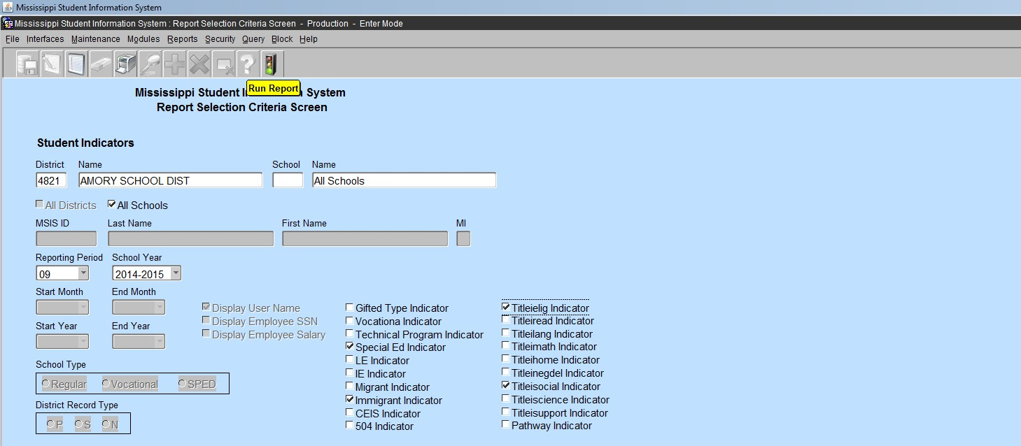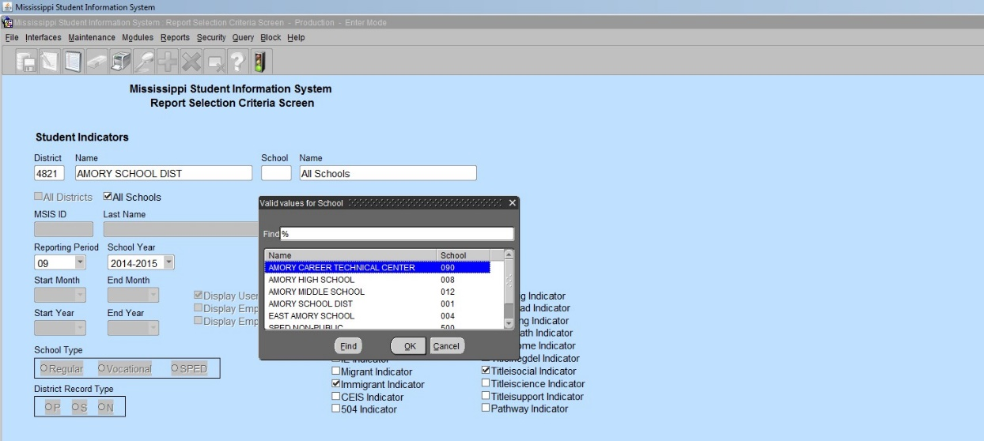

You can select all schools in the district or select a particular school in the district

The report appears in PDF with a “Y” indicator displayed for the program in which the student has been identified.

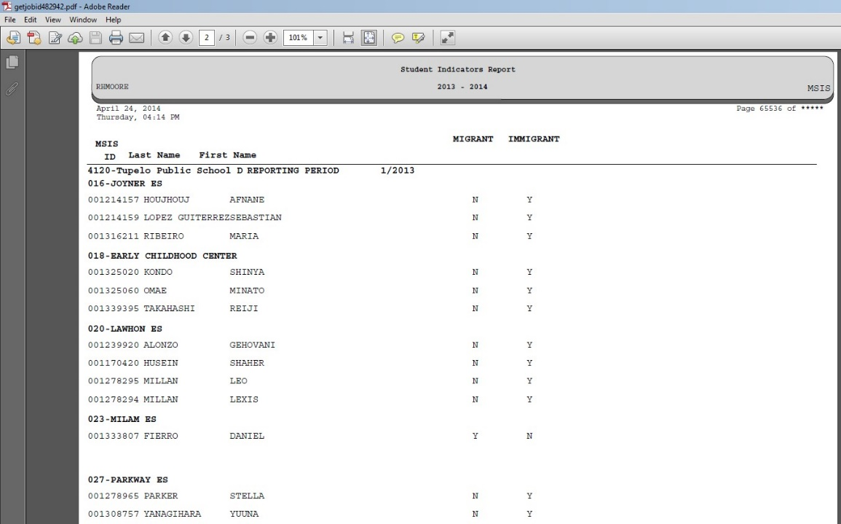

**Note:** Students can have more than one indicator selected in the SAP.

Please run all federal program reports on a monthly basis to verify students that are enrolled or receiving services in a particular Title program. This report can be used to correct errors in terms of identifying students receiving or eligible for Title services and/or support.

**Special Note:** If an enrolled student receiving services from a Title program withdraws, transfers or drops out from the school or district, the student will remain present on the report. You cannot remove the student from the report. This is due to the enrolled and served request from the USDoE in regard to students that must be reported annually in CSPR (USDoE).

Please print and maintain a copy of this report and all federal reports listed previously in this manual until the next monthly data file has been submitted to MDE.

* + - Print a copy of the reports **After** the submission of **Month 9 (end of school year)**

file to **MDE** on or before **June 25.**

* + - Please maintain copies of each report until **Month 1** of the upcoming **school year**

has been **Approved**.

* + - **MSIS closes July 1 and reopens August 1** (dates are subject to change with proper notification). Access to MSIS data from the previous school year will not be accessible or only available in ***view mode only***.
    - All students listed on each report must be identified by **Month 1, September 30,** each school year in the SAP. Verification of students must be done monthly in MSIS.
    - Please subscribe to **MSIS Blast**

**DISTRICT TIMELINE**

TIMELINE – You will find events that are due each month.

Financial Exchange Transaction System (FETS)

- All district data due no later than October 15

Career and Technical Education

- District changes due last week of every month

Child Nutrition

- Districts must enter/correct student lunch data status by mid-November

- Districts must submit through mdeapps@mdek12.org the batch processing of student lunch data

files (October-November)

Mississippi Student Information Systems (MSIS)

- District-level data

- Personnel data

- School Board member data

- Student-level data

Student Discipline and Incidents Reports

- Incidents shown under Persistently Dangerous School Category - Report Due within 72 hours (see

the Incidents and Dispositions Reportable to MSIS Manual)

- All other discipline and incident reports - Report Due Date: 10th of each calendar month-October

through June

JULY and AUGUST

- Access to ACCRED Live Data Reports

- District and school demographics

- District must enter Pay Scale in MSIS by the last business day in July

- District personnel data (Public, Special, and Non-Public)

- District Post Graduate Plan data

- Initial Student Load Transaction files (ISL files)

- Summer School Files (SSD files)

- Good Cause Exemption deadline will be August 15th

SEPTEMBER

- Districts must submit Summer School Files (SSD files) by 2nd Monday in September

- Districts must submit Initial Student Load Transaction files (ISL files) by noon September 30th

- Any adjustments to graduates and completers and promotions must be updated on the Update

Student Grades screen (Update Promotion tab) by September 30th, prior to Month 01 files being sent to MSIS

- Each school must have MSIS IDs and ownership of all students before submitting the Month 01

file

- Districts should start submitting Month 01 Monthly Days Taught Data Transaction (MDT files)

and Monthly Student Data Transaction (MSD files) on September 30th

- Districts must enter and approve personnel data by September 30th (Public, Special, and Non-

Public)

- Beginning September 1st Certification update for MSIS is run daily

- School Board member data is due to be updated no later than September 1st

OCTOBER

- Districts must submit/approve Month 01 Monthly Student Data Transaction (MSD files) by

October 10th

- Summer Activity Deadline – Oct 27th by 12 noon

- Incoming August/September Kindergarten student deadline is October 10th

- Districts must continue to update personnel data (Public, Special, and Non-Public)

- Mississippi Adequate Education Program (MAEP) edits are run as districts are approved

NOVEMBER

- Districts must submit/approve Month 02 Monthly Student Data Transaction (MSD files) by

November 10th

- Incoming October Kindergarten student deadline is November 10th

- District must update Special Education students using Special Education screens

- Districts must enter and correct student lunch data status by mid-November

- Districts must continue to update personnel data. Districts must approve personnel changes in

order for MAEP edits to run at night

- MAEP edits are run as districts are approved

DECEMBER

- All districts (public, non-public, and special) must have all personnel data entered in MSIS no later

than noon on December 7th so that the data will be included on the snapshot and Accreditation

edits and all year-end personnel reports can run from the snapshot data

- Districts will continue to make updates and approval to personnel in MSIS until the deadline on

December 7th (12 noon) at which time the rights to General/Schedule Entry screen are taken

away from the districts.

- MAEP edits are run as districts are approved

- Accreditation Edits are run for public, non-public, and special schools

- Access to ACCRED Live Data Reports is removed on December 10th .

- On December 1st only Daily Student Data Transaction (DSD files) are processed, all other files are

held until the next day for processing

- Snapshot of December 1 Special Education data is taken

- Districts must submit/approve Month 03 Monthly Student Data Transaction (MSD files) by

December 10th. MSD files will not process until the SPED December 1 child count is taken

- Incoming November Kindergarten student deadline is December 10th

- Data for Ed Directory is pulled from MSIS

JANUARY

- Districts must submit/approve Month 04 Monthly Student Data Transaction (MSD files) by

January 13th

- Incoming December Kindergarten student deadline is January 13th

- School Board member data is due to be updated no later than January 31st

- Rights to the General/Schedule Entry screen are restored after Christmas Break.

FEBRUARY

- Districts must submit/approve Month 05 Monthly Student Data Transaction (MSD files) by

February 10th

- Incoming January Kindergarten student deadline is February 10th

MARCH

- Districts must submit/approve Month 06 Monthly Student Data Transaction (MSD files) by March

10th - Incoming February Kindergarten student deadline is March 10th

APRIL

- Districts must submit/approve Month 07 Monthly Student Data Transaction (MSD files) by April

10th

- Incoming March Kindergarten student deadline is April 10th

MAY

- Districts must submit/approve Month 08 Monthly Student Data Transaction (MSD files) by

May 10th

- District must enter next school year’s calendar in MSIS District Events by May 30th

JUNE

- Districts must submit/approve Month 09 Monthly Student Data Transaction (MSD files) (10 days

after student’s last day of school)

- Districts must use the Year End Student Transfer screen to move students from one school to

another before records are built for the new school year. Last Day is June 30.

- Districts may submit Initial Student Load Transaction files (ISL files) from June 1 to September 30.

This is only for students who are under the age of 7 and need MSIS Ids

- Districts must submit Monthly Student Historical File (MSH file) as soon as Month 9 is completed - Graduation Option deadline for seniors is June 30th .

- Districts must complete Summer Program Report Entry screen for all schools offering summer

programs

- Districts must complete Teacher Absence Information. Last Day is June 30.

- MSIS is closed for maintenance on June 30.

SUMMER ACTIVITIES

- Districts may submit Initial Student Load Transaction Files (ISL files) to MSIS from June 1 st until

September 30th. This is only for students who are under the age of 7 by September 1st and do

not already have MSIS IDs.

- Districts may submit Summer School Files (SSD files) to MSIS from June 1 st until the 2nd Monday

in September.

- Districts (Public, Special, & Non-Public) should roll Personnel data from last school year and begin

working on Personnel for the new school year. Rolling Personnel also rolls Sped Student Data to

the new school year.

- Districts should update District and School Demographics for the new school year and make

changes during the school year as needed. School Board Member data should be updated as

needed also.

- Make adjustments to Graduates/Completers and Promotions/Non-Promotions on the Update

Student Grades screen (Update Promotion tab).

- The post-graduate plans for the students who are prior-year graduates/completers should be

entered in MSIS by August 31st using the Post-Graduate Plans screen.

TYPICAL MONTHLY PROCESS

- Each school should have MSIS IDs for and ownership of all of their students by the end of the

reporting month.

- Send Daily Student Data (DSD) files as needed to change a student’s Special Education status (Y

or N) and/or report incidents.

- Create MSD files and run them against the pre-processor to check that student and teacher

schedules are matching, school has ownership of the students, etc. prior to sending MSD file to

MSIS.

- Personnel should be approved each day that changes are made so the MAEP and Accreditation

procedures will run at night for the approved districts.

- Begin submitting Reporting Month (MDT and MSD) files at noon on last school day of reporting

month. (If the last day of the month falls on a weekend then file submission begins at noon on

the last Friday of the month).

- Once a school has a Success, run Pre-Approved Monthly Attendance Report and all Holding Area

reports.

- Check the data on the reports to insure accuracy of submitted data. Keep hard copies of Holding

Area reports or save PDF files of Holding Area reports for auditing purposes. Approve school in

MSIS if data is correct in Holding Area. Once all schools are approved, approve the district. The

deadline for a reporting month is the 10th of the following month.

IN JULY:

•MSIS will be unavailable on July 1 st .

- Build ownership files for new school year.

- Roll data that needs to be rolled (personnel, etc).

- Run procedure to increase Years of Experience by 1 on employees who had 100% District

Time previous school year.

- Changes will be active when system comes back up.

•Business Managers can start submitting financial data on July 2 nd .

Note: You can view more information on the Timeline located on the MSIS Information website under Timeline (<https://www.mdek12.org/OTSS/MSIS/Calendar>).

If you need help with any of the above information, you will need to submit your request through Footprints at: (https://servicedesk.mde.k12.ms.us/MRcgi/MRentrancePage.pl ) or email mdeapps@mdek12.org .

# Glossary

**Disposition:** the disciplinary action decided upon by the school or district administration to be completed by a student before returning to the classroom.

**Daily Student Data Transaction File (DSD**)Submit on a daily basis if you suspend or expel a student for a violent act OR if the status of a Special Education student changes. This file must be submitted within the month the incident occurred. If you cannot submit during the month of the incident (the incident happened on the last day of the month, but the district didn't take action until the 3rd of the next month), do not submit a DSD file. The student information will be updated with the MSD file.

Some incidents should be sent within 72 hours of the incident. These are Fighting, Homicide, Kidnapping, Mayhem, Poisoning, Rape, Robbery, Staff Assault, Stalking, Sexual Battery, and Weapon Possession.

You can get a complete list of incidents reportable in MSIS from the MSIS Information page at <http://www.mde.k12.ms.us/management-information-systems/ms-student-information-system-> (msis)/for-students. This document lists the incidents and dispositions to be reported in MSIS. Definitions of each incident code are included.

**Incident:** the action/crime conducted by a student, on and off campus, during the school year that requires a disciplinary action to be decided upon by school or district administration.

**Monthly Student Data Transaction File (MSD**) Submit one successful MSD per school per reporting period. This file contains students' schedules, demographics, emergency information, incidents, attendance, enrollments, withdrawals, class schedules, program indicators and grades with credits received. This information has been entered at the home school into the school administrative package.

**Monthly Days Taught Data Transaction File (MDT**) Submit one MDT per school per reporting period. This file should be submitted first for your monthly reports. Once you have a Success, you do not have to submit this file again until the next reporting period. This tells MSIS how many days were taught at this school for each grade for this reporting period.

**Reporting Period** – the student school attendance month **NOT** a calendar month. Please refer to the district timeline listed above.

**Student Administrative Package** -SAP –is a district-level software package that allow school districts to manage student, personnel and other pertinent school data on a daily basis. The software must have the capabilities of exporting data into MSIS. School districts select and purchase the school software company. *MDE employees are strictly prohibited from the decision and purchasing of the software at the public and non-public district level. MDE employees are forbidden* ***access*** *to the software packages purchased by the districts.*

**Start Month/End Month** – Standard Calendar Months

**Targeted Assistance School** - primarily addressed in [**section 1115 of Title I, Part A,**](http://www2.ed.gov/legislation/ESEA/sec1115.html) is one that receives Part A funds yet is ineligible or has chosen not to operate a Title I schoolwide program. The term "targeted assistance" signifies that the services are provided to a select group of children--those identified as failing, or most at risk of failing, to meet the State's challenging content and student performance standards--rather than for overall school improvement, as in schoolwide programs. Like schoolwide program schools, the goal of a targeted assistance school is to improve teaching and learning to enable Part A participants to meet the challenging State performance standards that all children are expected to master. To accomplish this goal, a targeted assistance program must be based on effective means for improving achievement of participating children; use effective instructional strategies that give primary consideration to extended-time strategies, provide accelerated, high-quality curricula, and minimize removing children from the regular classroom during regular school hours; coordinate with and support the regular education program; provide instruction by highly-qualified and trained professional staff; and implement strategies to increase parental involvement

# Report Glossary

**Holding Area Report** – A report that is created in MSIS before the approval of the district MSD file and it allows verification of the data. go to REPORTS>STUDENT ROSTER>HOLDING AREA and run the report and verify that all students have been sent. Other Holding Area reports should also be run at this time.

These reports are: Holding Area Student Entries, Holding Area Student Withdrawals, Holding Area Incidents/Dispositions, Holding Area Student Indicators, Holding Area Absences, Holding Area Carnegie Unit with No Credit (important for Month 09), and Holding Area Vocational Student Indicators. A hard copy or PDF file of each month’s Holding Area reports should be saved for auditing purposes. These reports are accessed by going to REPORTS>STUDENT DATA>HOLDING AREA and then selecting the desired report. If the reports look okay, then go to the APPROVE IMPORTED STUDENT DATA screen and click in the Approved field for that school. The date will default to the current date. You WILL NOT be able to approve a school if the PRE-APPROVED MONTHLY ATTENDANCE REPORT has not been run. Click on the green diskette in the upper left corner to save the approval. Repeat this until all schools have been approved.

**Holding Area Student Indicators -** the report that is a list of students with a particular indicator selected in the SAP and/or last submitted in the MSD file that is in the Holding Area. The user can choose an indicator and run a listing of students with that indicator marked in the last submitted MSD file that is in the Holding Area. For example, the user could run a listing of all students marked as Gifted or a listing of Voc Ed students, or a listing of Special Ed students.

**Holding Area Vocational Student Indicators -** This report list student name, MSIS ID, Grade Level, Vocational Indicator, LEP Indicator, Capstone Indicator, Disabled Indicator, Disadvantaged Indicator, Nontraditional Indicator, Single Parent Indicator, and Displaced Homemaker Indicator for students in the selected school who have a Vocational Indicator of Y in the Holding Area. This allows you to verify the data before approving the school for the reporting month.

**Holding Area Student Entries -** This report lists the student's name, MSIS ID, and grade level alphabetically by school based on data in the Holding Area. This allows you to see the students that were sent in with an entry in the MSD file. The District Student Administrators and School Student Administrators have rights to run this report.

**Holding Area Student Withdrawals –** This report lists the student's name, MSIS ID, and grade level alphabetically by school based on data in the Holding Area. This allows you to see the students that were sent in with a withdrawal in the MSD file. The District Student Administrators and School Student Administrators have rights to run this report.

**Holding Area Incidents/Dispositions -** This report lists the incident description and disposition code with totals of each that are in the Holding Area. This allows you to see the incidents/dispositions that were sent in the MSD file. The District Student Administrators and School Student Administrators have rights to run this report.